

SLIFE – SECONDHAND MARKETPLACE PLATFORM FOR HOA LAC STUDENTS

Report 3 – Software Requirement Specification

– HANOI, JANUARY 2026 –
Table of Contents
I. Project Report 3
1. Status Report 3
2. Team Involvements 3
3. Issues/Suggestions 3
II. Software Requirement Specification 4
1. Overall Description 4
1.1 Product Overview 4
1.2 Business Rules 5
2. User Requirements 6
2.1 System Actors 6
2.2 Use Cases 6
3. Functional Requirements 8
3.1 System Functional Overview 8
3.2 <<Feature Name 1>> 10
3.3 <<Feature Name 2>> 10
4. Non-Functional Requirements 11
4.1 External Interfaces 11
4.2 Quality Attributes 12
5. Other Requirements 14
5.1 Appendix1 - Messages List 14
5.2 Appendix2 - … 14
5.3 … 14

I. Record of Changes
Date | A*  M, D | In charge | Change Description
27/01/2024 | A | Hoang Anh Tu | Add II.2.1 Actors  Add II.2.2 Use Cases  Add III.3. Functional Requirement
28/01/2026 | A | La Thi Thanh Hoa | Add 1.1 Context diagram
28/01/2026 | A | Tran Thi Ngoc Anh | Add II.3.1 System Functional Overview
29/01/2026 | A | Do Thanh An | Add 2.2.1.1 Seller Diagram
29/01/2026 | A | Do Thanh An | Add 2.2.1.2 Seller Diagram
29/01/2026 | A | Le Duc Viet | Add 4. Non-Functional Requirement
29/01/2026 | A | Le Duc Viet | Add 5. Requirement Appendix
28/01/2026 | A | La Thi Thanh Hoa | Add 1.2.1 Product Purchase and Giveaway Flow
01/02/2026 | M | La Thi Thanh Hoa | Modified 1.2.1 Product Purchase and Giveaway Flow
01/02/2026 | M | La Thi Thanh Hoa | Modified 1.1 Context diagram
01/02/2026 | A | Le Duc Viet | Add I 1.2.2 Create Work Flow
01/02/2026 | M | Le Duc Viet | Modified I 1.2.2 Create Work Flow
01/02/2026 | M | Tran Thi Ngoc Anh | Modified II.3.1 System Functional Overview
01/02/2026 | M | Le Duc Viet | Modified II 5.1 Business Rules
04/02/2026 | M | Le Duc Viet | Modified II 4.Non-Functional Requirement
05/02/2026 | M | Le Duc Viet | Modified II 3. Screen Specification
*A - Added M - Modified D - Deleted

II. Software Requirement Specification

1. Product Overview
The SLIFE second-hand marketplace platform for Hoa Lac students is an online system that supports monitored buying and selling activities. The context diagram illustrates the system boundary and its interactions with external entities, including Buyers, Sellers, Guests, and Administrators. Buyers and Sellers exchange data with the system such as product listings, chat messages, saved items, reports, authentication requests, and transaction-related information. Guests can only view public listings and seller profiles with ratings. Administrators interact with the system by reviewing reports, performing moderation actions, and managing users and listings, while receiving reports, user data, and moderation status information from the system. The platform also integrates with external services, including Google SSO for authentication and a Mail Gateway for sending and receiving email-related information. The diagram presents only high-level data flows between the system and external actors, without describing internal system processes.

1.1 Context diagram
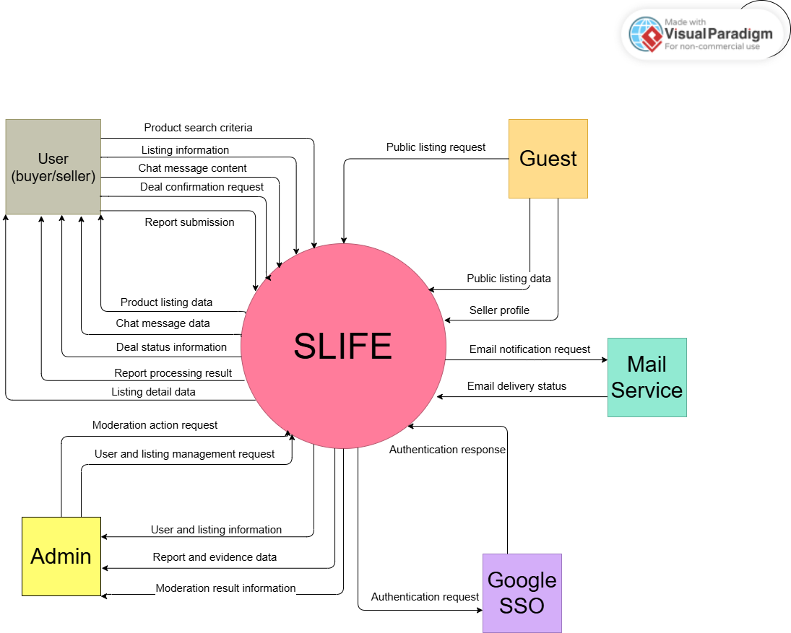

1.2 Main Workflows

1.2.1 Product Purchase and Giveaway Flow
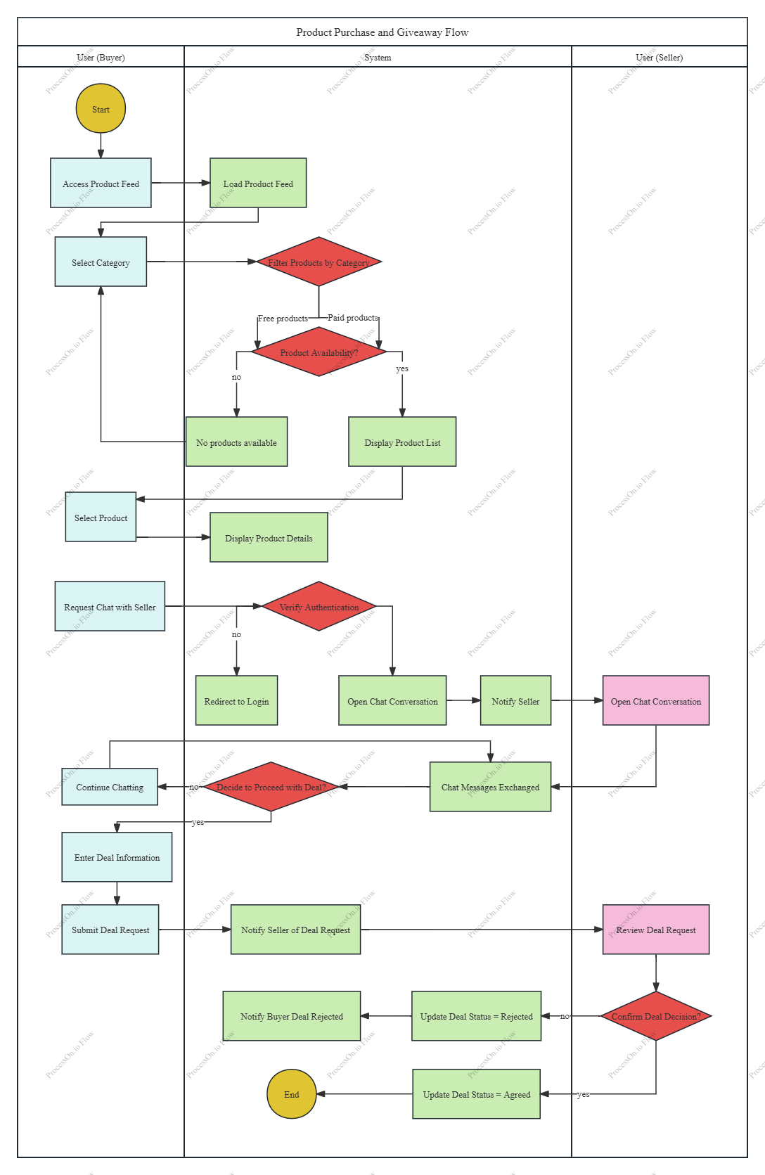

1.2.2 Create Listing Flow
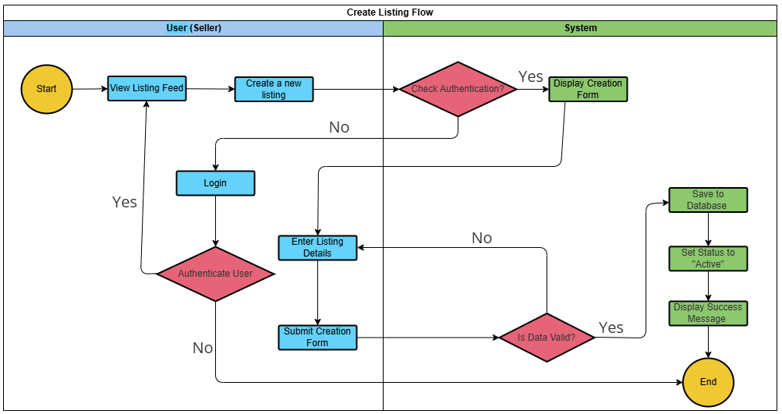

2. User Requirements

2.1 Actors

# | Actor | Description
1 | User (Seller) | A user who lists products on the system for sale. The seller can create, update, hide, or delete product information and manage orders related to their products.
2 | Admin | A system administrator responsible for managing users, products, and orders, as well as monitoring and maintaining overall system operations.
3 | Guest | Unauthenticated user, authorized for viewing only.
4 | User (Buyer) | Authenticated user, authorized for purchasing and interaction. Inherits all permissions from Guest.
5 | Google SSO | Google SSO is considered a secondary actor that interacts with the system for authentication purposes.
6 | Mail Service | An external email delivery service used to send system notifications such as account verification, deal confirmation, and moderation results.

2.2 Use Cases

2.2.1 Use Cases Diagram(s)

2.2.1.1 Seller Diagram
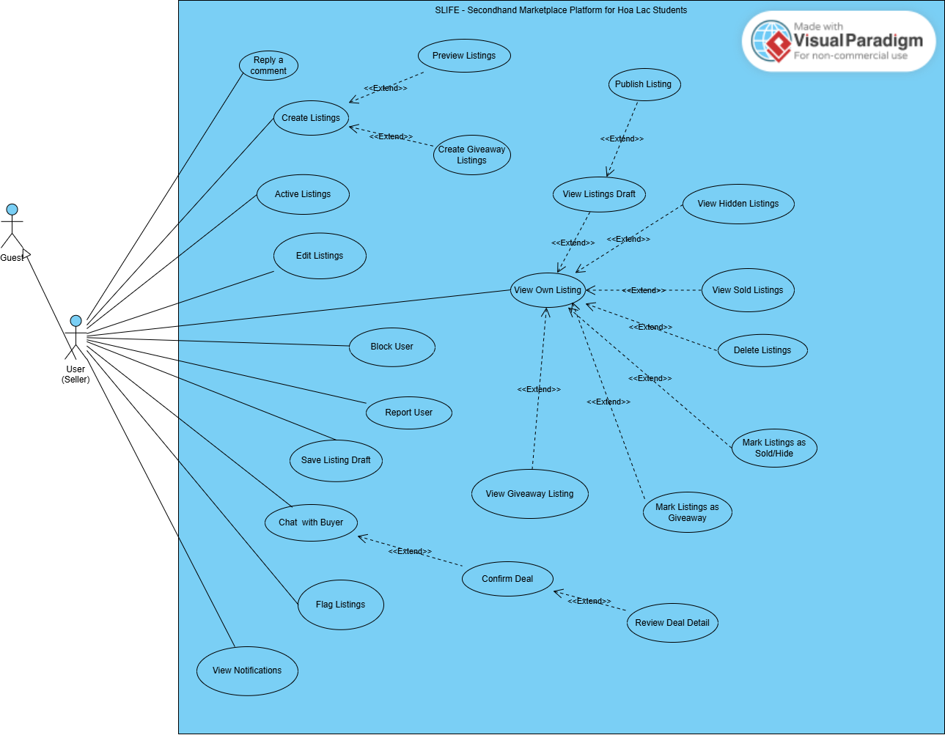

2.2.1.2 Admin Diagram
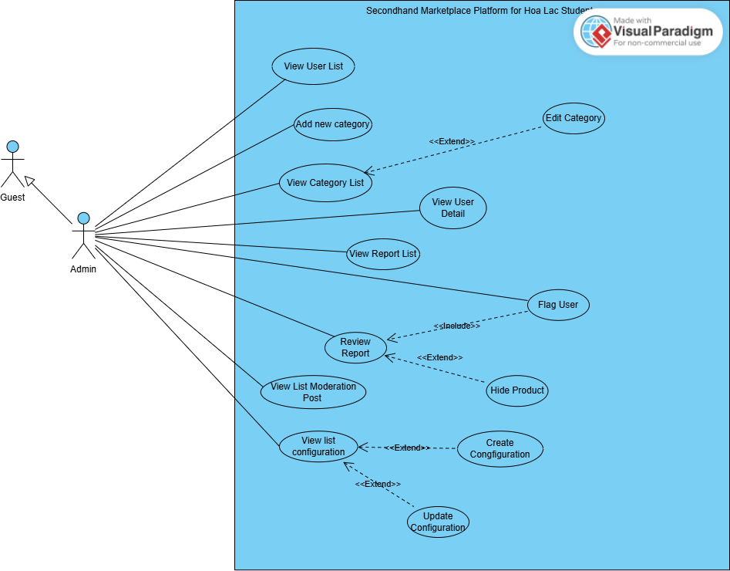

2.2.1.3 Buyer Diagram
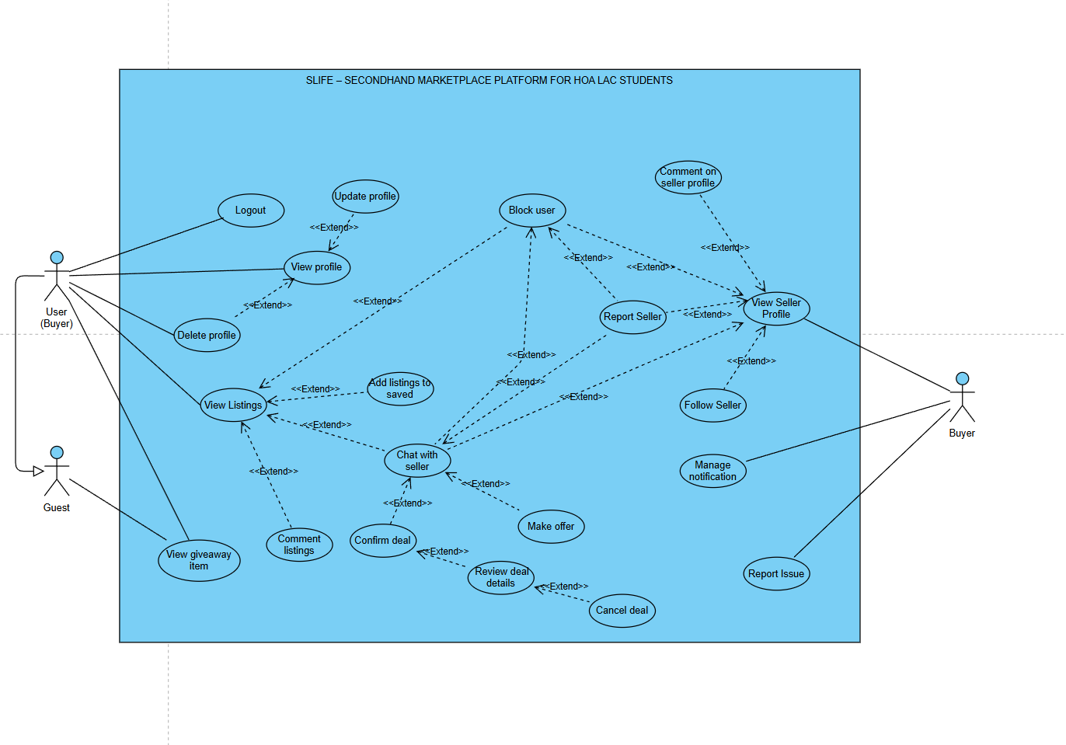

2.2.1.4 Guest Diagram
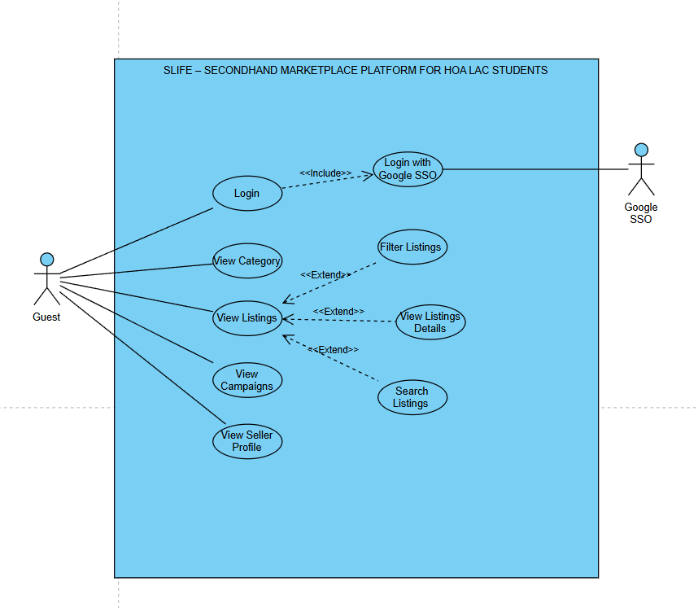

2.2.2 Descriptions

ID | Use Case | Actors | Use Case Description
01 | View Own Listing | User (Seller) | Seller views the list of listings that they have created, including status (draft, active, sold, hidden).
02 | Create Listings | User (Seller) | Seller creates a new listing by entering product information such as name, description, category, price, images, and quantity.
03 | Preview Listings | User (Seller) | Seller previews the listing as it will appear to buyers before publishing or updating it.
04 | Edit Listings | User (Seller) | Seller updates information of an existing product listing.
05 | Delete Listings | User (Seller) | Seller deletes a listing from the system.
06 | Mark Product as Sold | User (Seller) | Seller marks a listing as sold when the transaction is completed.
07 | Hide Listings | User (Seller) | Seller hides a listing from public view without deleting it.
08 | Active Listings | User (Seller) | Seller re-activates a previously hidden or sold listing.
09 | Save Listings Draft | User (Seller) | Seller saves a listing as a draft without making it visible to buyers.
10 | View Listings Draft | User (Seller) | Seller views all listings that are saved as drafts.
11 | Publish Listing | User (Seller) | Seller publishes a draft listing to make it publicly visible.
12 | View Sold Listings | User (Seller) | Allows the seller to view a list of listings that have been marked as Sold, so the seller can track items that are no longer available.
13 | View Hidden Listings | User (Seller) | Allows the seller to view a list of listings that are currently in Hidden status, meaning they are temporarily removed from public view.
14 | Create Giveaway Product | User (Seller) | Seller creates a product listing specifically for giveaway purposes.
15 | Mark Listing as Giveaway | User (Seller) | Seller marks an existing listing as a giveaway item.
16 | Comment on Listing | User | Buyer writes and posts public questions or comments directly below the Seller's listing.
17 | Reply a Comment | User (Seller) | Seller replies to comments posted by buyers on their product listings.
18 | Flag Listings | User (Seller/Buyer) | Allows a user to report (flag) a listing that is suspected to violate platform rules such as fraud, spam, prohibited items, or inappropriate content.
19 | Block User | User (Seller/Buyer) | Allows a user to block another user to prevent further interaction, messages, and viewing of each other’s listings..
20 | Report User | User (Seller/Buyer) | Seller reports another user for suspicious or rule-violating behavior.
21 | View List Moderation Post | Admin | Admin views the list of reports submitted by users for moderation.
22 | View Report Detail | Admin | Admin views detailed information of a selected report.
23 | Review Report | Admin | Admin reviews a report to determine appropriate moderation actions.
24 | Hide Product | Admin | Admin hides a product listing that violates platform rules.
25 | Rate Seller | User (Buyer) | Buyer provides a star rating and review regarding the Seller's reputation after the transaction is finalized.
26 | Chat with Buyer | User (Seller) | Seller communicates with buyers via the in-app chat system.
27 | Review Deal Detail | User (Seller/Buyer) | Allows a buyer or seller to view detailed information of a deal, including listing details, agreed price, and participant information, before the deal is confirmed.
28 | Confirm Deal | User (Seller/Buyer) | Allows the seller to confirm a deal after reviewing all deal details, finalizing the transaction and notifying the buyer.
29 | Chat with Seller | User (Buyer) | Buyer opens a real-time chat with the Seller to inquire about product details and arrange delivery/pickup.
30 | Make Offer | User (Buyer) | The buyer proposes a new price lower than the listed price. Seller can Accept to update the transaction price or Reject.
31 | Save Listing | User(Buyer) | Buyer clicks the save icon to add the listing to their favorites list for tracking or future purchase.
32 | View Listings | Guest, User | User browses the list of products currently up for sale (Active status) at Hoa Lac campus on the Feed.
33 | View Listing Detail | Guest, User | Users view detailed information of a product, including description, price, images, condition, and pickup point.
34 | Search | Guest, User | User search for listings by keywords, product categories, or price range filters.
35 | View giveaway item | Guest, User | User view list of giveaway items
36 | View list saved | User | Buyer views a collection of all previously saved listings.
37 | Remove saved | User | Buyer removes a listing from the saved list by clicking the "un-save" icon.
38 | View Dashboard | Admin | Admin views system overview information such as total users, listings, and reports.
39 | View User List | Admin | Admin views the list of all users registered in the system.
40 | View User Detail | Admin | Admin views detailed information of a selected user account.
41 | View Configuration List | Admin | Allows the admin to view the list of all configurations available in the system, including their basic information and current status.
42 | Create Configuration | Admin | Allows the admin to create a new configuration by entering required configuration information and saving it to the system.
43 | Update Configuration | Admin | Allows the admin to update the information of an existing configuration, including configuration details and status.
44 | View Category List | Admin | Admin views the list of product categories available in the system.
45 | Add New Category | Admin | Admin adds a new product category to the system.
46 | Edit Category | Admin | Admin edits information of an existing product category.
47 | Login with email edu | Guest, User | Users use Google Login to access the system based on their role.
48 | View notification | User | The user views a list of notifications regarding new messages, accepted offers, or system updates.
49 | Logout | User | Allows the user to terminate their current session and clear authentication data.
50 | Report Issue | User | Allows users to report technical bugs or system errors to the administrators.
51 | Unfollow User | User | Allows a user to stop following another user to no longer receive their listing updates.
52 | Follow User | User | Buyer follows another user (typically a reputable seller) to receive notifications when they post new listings.
53 | View Profile | User | Users view their personal information including avatar, name, phone number, and reputation score.
54 | Update Profile | User | Users edit personal info such as avatar, bio, or update their contact methods.
55 | Auto-confirm | System | The system automatically switches transaction status to "Completed" after 3 days if the Buyer does not manually confirm or file a report.

2.3 Use Case Specifications

2.3.1 UC-01 View Listing

Primary Actors | Seller | Secondary Actors | None
Description | Allows the seller to view the list of all product listings they have created on the platform, including the current status of each listing such as Active, Sold, or Hidden.
Preconditions | PRE-01: The seller has a registered account in the system.  PRE-02: The seller has at least one product listing created in the system.
Postconditions | POST-01: The system displays the list of product listings belonging to the seller.  POST-02: Each listing shows basic information such as product name, price, and current status.
Normal Flows | 1. User logs into the system  2. The user clicks on the “My Listings” button on the seller dashboard.  3. The system sends a request to retrieve all product listings created by the seller.  4. The system validates the user’s role as Seller.  5. The system retrieves product listing data from the database.  6. The system displays the list of product listings with their statuses (Active, Sold, Hidden).
Alternative Flows | AF-01: No product listings available  - If the seller has no product listings, the system displays a message indicating that no listings are found.  - Users may click the “Create New Listing” button to add a product.
Business Rules | BR-01, BR-02

2.3.2 UC-02 Create Listing

Primary Actors | Seller | Secondary Actors | None
Description | Allows the seller to create a new product listing by entering product information such as name, category, price, description, and images.
Preconditions | PRE-01: The seller has a registered account in the system.  PRE-02: The seller has logged into the system successfully.
Postconditions | POST-01: A new product listing is created with status Active.  POST-02: The listing is stored in the system database.
Normal Flows | 1. User logs into the system  2. The user clicks on the “Create Listing” button on the seller dashboard.  3. The system displays the product listing creation form.  4. The user enters product details (name, category, price, description, images).  5. User clicks the “Submit” button  6. The system validates the entered information.  7. The system saves the new product listing and sets its status to Active.  8. The system displays a success message to the user.
Alternative Flows | AF-01: Invalid or missing information  - If required fields are missing or invalid, the system displays an error message.  - Users are prompted to correct the information and resubmit.
Business Rules | BR-03

2.3.3 UC-03 Preview Listing

Primary Actors | Seller | Secondary Actors | None
Description | Allows the seller to preview the product listing as it will appear to buyers before publishing or updating it.
Preconditions | PRE-01: The seller has logged into the system successfully.  PRE-02: The seller is creating a new product listing or editing an existing product listing.  PRE-03: Product information has been entered in the listing form.
Postconditions | POST-01: The system displays a preview of the product listing based on the entered information.  POST-02: No product listing data is saved or published at this stage.
Normal Flows | 1. User logs into the system  2. The user clicks on the “Create Listing” or “Edit” button.  3. The system displays the product listing form.  4. The user enters or updates product information (name, category, price, description, images, quantity).  5. The user clicks the “Preview” button.  6. The system generates a preview using the entered product information.  7. The system displays the product listing preview as it will appear to buyers.
Alternative Flows | AF-01: Required information missing  - If required product fields are incomplete, the system displays an error message.  - Users are prompted to complete the information before previewing.
Business Rules | None

2.3.4 UC-04 Edit Listing

Primary Actors | Seller | Secondary Actors | None
Description | Allows the seller to update information of an existing product listing such as name, price, description, images, or quantity.
Preconditions | PRE-01: The seller has logged into the system successfully.  PRE-02:The product listing already exists and belongs to the seller.
Postconditions | POST-01: Product information is updated successfully.  POST-02: Updated information is saved in the system database.
Normal Flows | 1. User logs into the system  2. The user clicks on the “View Product List” button on the seller dashboard.  3. The system displays the list of the seller’s product listings.  4. The user selects a product and clicks the “Edit” button.  5. The system displays the product edit form with existing information filled in.  6. The user updates the product information.  7. The user clicks the “Save Changes” button.  9. The system validates the updated information.  10. The system saves the changes and displays a success message.
Alternative Flows | AF-01: Required information missing  - If required product fields are incomplete, the system displays an error message.
Business Rules | BR-04

2.3.5 UC-05 Delete Listing

Primary Actors | Seller | Secondary Actors | None
Description | Allows the seller to delete a product listing from the system.
Preconditions | PRE-01: The seller has logged into the system successfully.  PRE-02:The product listing exists and belongs to the seller.
Postconditions | POST-01: The product listing is removed from the system database.
Normal Flows | 1. User logs into the system  2. The user clicks on the “View Product List” button on the seller dashboard.  3. The system displays the seller’s product listings.  4. The user selects a product and clicks the “Delete” button.  5. The system displays a confirmation dialog.  6. User confirms deletion.  7. The system deletes the product listing.  9. The system displays a success message.
Alternative Flows | AF-01: User cancels deletion  - The system closes the confirmation dialog and keeps the product listing unchanged.
Business Rules | BR-05

2.3.6 UC-06 Mark Listing as Sold

Primary Actors | Seller | Secondary Actors | None
Description | Allows the seller to mark a product listing as sold after completing a transaction.
Preconditions | PRE-01: The seller has logged into the system successfully.  PRE-02:The product listing exists and is active.
Postconditions | POST-01: Product status is updated to Sold.
Normal Flows | 1. User logs into the system  2. The user clicks on the “View Product List” button on the seller dashboard.  3. The system displays the seller’s product listings.  4. The user selects a product and clicks the “Mark as Sold” button.  5. The system updates the product status to Sold.  6. The system displays a confirmation message.
Alternative Flows | AF-01: Product already marked as sold  - The system displays a notification that the product is already sold.
Business Rules | None

2.3.7 UC-07 Hide Listing

Primary Actors | Seller | Secondary Actors | None
Description | Allows the seller to hide an existing product listing so that it is no longer visible to buyers, while keeping the product data stored in the system.
Preconditions | PRE-01: The seller has logged into the system successfully.  PRE-02: The product listing exists and is active.
Postconditions | POST-01: The product listing status is changed to Hidden.  POST-02: The product listing is no longer visible to buyers.
Normal Flows | 1. User logs into the system  2. The user clicks on the “View Product List” button on the seller dashboard.  3. The system displays the seller’s product listings.  4. The user selects a product and clicks the “Hide Product” button.  5. The system displays a confirmation dialog.  6. The user clicks the “Confirm” button.  7. The system updates the product status to Hidden and displays a success message.
Alternative Flows | None
Business Rules | BR-02

2.3.8 UC-08 Active Listing

Primary Actors | Seller | Secondary Actors | None
Description | Allows the seller to relist a previously hidden or sold product listing, making it active and visible to buyers again.
Preconditions | PRE-01: The seller has logged into the system successfully.  PRE-02:The product listing status is Hidden or Sold.
Postconditions | POST-01: The product listing status is changed to Active.  POST-02: The product listing becomes visible to buyers.
Normal Flows | 1. User logs into the system  2. The user clicks on the “View Product List” button on the seller dashboard.  3. The system displays the seller’s product listings.  4. The user selects a hidden or sold product and clicks the “Relist Product” button.  5. The system displays a confirmation dialog.  6. The user clicks the “Confirm” button.  7. The system updates the product status to Hidden and displays a success message.
Alternative Flows | None
Business Rules | BR-07

2.3.9 UC-09 Save Listing Draft

Primary Actors | Seller | Secondary Actors | None
Description | This use case allows the seller to save a product listing in Draft status while creating or editing a listing. Draft listings are stored in the system but are not visible to buyers and can be edited or published later.
Preconditions | PRE-01: The seller has logged into the system successfully.
Postconditions | POST-01: The product listing is saved with status Draft.  POST-02: The draft listing is stored in the system and visible only to the seller.
Normal Flows | 1. User logs into the system  2. Seller clicks the “Create Listing” button.  3. Seller enters or updates product information.  4. Seller clicks the “Save as Draft” button.  5. The system saves the product listing with status Draft.
Alternative Flows | AF-01: Invalid input data  - The system displays an error message and does not save the draft.
Business Rules | BR-08

2.3.10 UC-10 View Listing Draft

Primary Actors | Seller | Secondary Actors | None
Description | This use case allows the seller to view a list of all listings that are currently saved in Draft status.
Preconditions | PRE-01: The seller has logged into the system successfully.  PRE-02: The order exists and is related to the seller’s products.
Postconditions | POST-01: The system displays a list of draft listings belonging to the seller.  POST-02: Each draft listing shows basic information such as title and last updated time.
Normal Flows | 1. User logs into the system  2. Seller clicks the “My Listings” button on the Seller Dashboard.  3. Seller clicks the “Draft Listings” tab.  4. The system displays the list of draft listings.
Alternative Flows | AF-01:No draft listings found  - If no draft listings exist, the system displays a message indicating that no draft listings are available.
Business Rules | BR-08

2.3.11 UC-11 Publish Listing

Primary Actors | Seller | Secondary Actors | None
Description | This use case allows the seller to publish a draft listing, changing its status from Draft to Active, so that it becomes visible to buyers on the platform.
Preconditions | PRE-01: The seller has logged into the system successfully.  PRE-02: The product listing exists in Draft status.
Postconditions | POST-01: The product listing status is changed from Draft to Active.  POST-02: The listing becomes visible to buyers.  POST-03: The published listing appears in buyer search results.
Normal Flows | 1. User logs into the system  2. Seller clicks the “My Listings” button on the Seller Dashboard.  3. Seller clicks the “Draft Listings” tab.  4. Seller selects a draft product listing.  5. Seller clicks the “Publish Listing” button.  6. The system updates the listing status to Active.  7. The system displays a confirmation message indicating successful publication.
Alternative Flows | None
Business Rules | None

2.3.12 UC-12 View Sold Listings

Primary Actors | Seller | Secondary Actors | None
Description | This use case allows the seller to view a list of listings that have been marked as Sold, so the seller can track items that are no longer available.
Preconditions | PRE-01: The seller has logged into the system successfully.  PRE-02: The seller has at least one product listing with status Sold.
Postconditions | POST-01: The system displays a list of sold product listings belonging to the seller.  POST-02: Each sold listing shows basic information such as product title, price, and sold date.
Normal Flows | 1. User logs into the system  2. Seller clicks the “My Listings” button on the Seller Dashboard.  3. Seller clicks the “Sold Listings” tab.  4. The system displays the list of sold product listings.
Alternative Flows | AF-01: No sold listings available  - If no sold listings are found, the system displays a message indicating that no sold listings are available.
Business Rules | None

2.3.13 UC-13 View Hidden Listings

Primary Actors | Seller | Secondary Actors | None
Description | This use case allows the seller to view a list of product listings that are currently in Hidden status, meaning they are temporarily removed from public view.
Preconditions | PRE-01: The seller has logged into the system successfully.  PRE-02: The seller has at least one product listing with status Hidden.
Postconditions | POST-01: The system displays a list of hidden product listings belonging to the seller.  POST-02: Each hidden listing shows basic information such as product title and last updated date.
Normal Flows | 1. User logs into the system  2. Seller clicks the “My Listings” button on the Seller Dashboard.  3. Seller clicks the “Hidden Listings” tab.  4. The system displays the list of hidden product listings.
Alternative Flows | AF-01: No hidden listings available  - If no hidden listings are found, the system displays a message indicating that no hidden listings are available.
Business Rules | None

2.3.14 UC-14 Create Giveaway Listing

Primary Actors | Seller | Secondary Actors | None
Description | This use case allows the seller to create a listing marked as a giveaway item (free item) for other users.
Preconditions | PRE-01: User logs into the system successfully.
Postconditions | POST-01: A new giveaway product is created and stored in the system.  POST-02: The giveaway product is visible in the product list with price set to 0.
Normal Flows | 1. The user logs into the system.  2. Seller selects the Create Listing function.  3. Seller enters listing information (name, description, category, images).  4. The system sets the listing price to 0.  5. Seller submits the product form.  6. The system displays the created giveaway listing in the product list.  7. The system saves the giveaway product and displays a confirmation message.
Alternative Flows | AF-01: Invalid input data  - If required fields are missing or invalid, the system displays an error message and requests the seller to correct the information.
Business Rules | BR-17

2.3.15 UC-15 Mark Listing as Giveaway

Primary Actors | Seller | Secondary Actors | None
Description | This use case allows the seller to convert an existing listing into a giveaway item.
Preconditions | PRE-01: User logs into the system successfully.  PRE-02: The product already exists and belongs to the seller.
Postconditions | POST-01: The selected product is updated as a giveaway item.  POST-02: The product price is set to 0.
Normal Flows | 1. The user logs into the system.  2. Seller opens the View Listing screen.  3. Seller selects a listing to edit.  4. Seller chooses the Mark as Giveaway option.  5. The system updates the listing price to 0.  6. The system saves the updated listing information.  7. The system displays the updated listing details.
Alternative Flows | None
Business Rules | BR-18, BR-19

2.3.16 UC-16 Comment on Listing

Primary Actors | User | Secondary Actors | None
Description | Allows a buyer to write and post public questions or comments directly below the seller's listing.
Preconditions | PRE-01: The user has logged into the system successfully.
Postconditions | POST-01: The comment is stored and displayed publicly under the listing.
Normal Flows | 1. The user views the listing detail.  2. The user enters a comment in the input field.  3. The user clicks the "Send" button.  4. The system validates the content.  5. The system saves and displays the comment immediately
Alternative Flows | AF-01: Restricted User: If the user is restricted, the system denies posting the comment
Business Rules | BR-32, BR-44

2.3.17 UC-17 Reply a Comment

Primary Actors | Seller | Secondary Actors | None
Description | Allows the seller to reply to comments posted by buyers on their product listings in order to provide additional information or clarify questions.
Preconditions | PRE-01: User logs into the system successfully.  PRE-02: The product listing belongs to the seller.  PRE-03: The product listing has at least one buyer comment.
Postconditions | POST-01: The seller’s reply is posted successfully.  POST-02: The reply is saved and displayed under the corresponding comment.
Normal Flows | 1. The user logs into the system.  2. The user clicks on the “View Product List” button.  3. The system displays the seller’s product listings.  4. The user selects a product and clicks the “View Comments” button.  5. The system displays the list of comments for the selected product.  6. The user enters a reply and clicks the “Reply” button.  7. The system saves the reply and displays it under the comment.
Alternative Flows | None
Business Rules | BR-14

2.3.18 UC-18 Flag Listing

Primary Actors | User | Secondary Actors | Administrator
Description | Allows a user to report (flag) a listing that is suspected to violate platform rules such as fraud, spam, prohibited items, or inappropriate content.
Preconditions | PRE-01: The seller has logged into the system successfully.  PRE-02: The product listing exists and is visible to the user.
Postconditions | POST-01: A report record is created for the flagged listing.  POST-02: The report status is set to Pending Review  POST-03: Admin can view the flagged listing for moderation.
Normal Flows | 1. User logs into the system  2. The user opens the Listing Detail page.  3. The user clicks the Flag / Report Listing button.  4. The system displays a list of report reasons (e.g. Scam, Spam, Prohibited Item, Offensive Content).  5. The user selects a report reason and optionally enters additional comments.  6. The user clicks the Submit Report button.  7. The system displays a confirmation message indicating the listing has been reported.
Alternative Flows | AF-01: User already reported this listing  - If the user has already flagged the same listing, the system displays a message indicating that the listing has already been reported by the user.
Business Rules | None

2.3.19 UC-19 Block User

Primary Actors | Seller | Secondary Actors | Administrator
Description | Allows a user to block another user to prevent further interaction, messages, and viewing of each other’s listings.
Preconditions | PRE-01: The seller has logged into the system successfully.  PRE-02: The target user exists in the system.
Postconditions | POST-01: The target user is added to the blocker’s blocked user list.  POST-02: The blocked user can no longer send messages or interact with the blocker.
Normal Flows | 1. User logs into the system  2. User opens the User Profile or Listing Detail page of another user.  3. The user clicks the Block User button.  4. The system displays a confirmation dialog.  5. User clicks Confirm Block.  6. The system displays a confirmation message that the user has been blocked.
Alternative Flows | None
Business Rules | None

2.3.20 UC-20 Report User

Primary Actors | Seller | Secondary Actors | None
Description | Allows the seller to report another user for suspicious behavior or violations of platform rules, such as spam, fraud, or abusive communication.
Preconditions | PRE-01: User logs into the system successfully.  PRE-02: The seller has interacted with the reported user via order, chat, or product comments.
Postconditions | POST-01: A report is created and stored in the system database.  POST-02: The report is added to the moderation queue for admin review.
Normal Flows | 1. The user logs into the system.  2. The user navigates to the order details, chat screen, or user profile.  3. The user clicks the “Report User” button.  4. The system displays the report submission form.  5. The user selects a report reason and enters additional details.  6. The user clicks the “Submit Report”* button.  7. The system saves the report and displays a confirmation message.
Alternative Flows | None
Business Rules | None

2.3.21 UC-21 View List Moderation Post

Primary Actors | Admin | Secondary Actors | None
Description | Allows the administrator to view the list of reports submitted by users that require moderation and further review.
Preconditions | PRE-01: Administrator has logged into the system successfully.
Postconditions | POST-01: The system displays the moderation queue containing reported users and product listings.
Normal Flows | 1. *Administrator logs into the system.*  2. The administrator clicks on the *“Moderation”* button.  3. The system retrieves all pending reports from the database.  4. The system processes report data.  5. The system displays the moderation queue.  6. The administrator views the list of reports.
Alternative Flows | AF-01: No reports available*  If there are no pending reports, the system displays an empty moderation queue with a notification message.
Business Rules | BR-33

2.3.22 UC-22 View Report Detail

Primary Actors | Admin | Secondary Actors | None
Description | This use case allows the administrator to view the list of reports submitted by users for moderation purposes. The report list includes basic information such as report type, reported user or product, report reason, and report status.
Preconditions | PRE-01: Administrator has logged into the system successfully.  PRE-02: At least one report exists in the system.
Postconditions | POST-01: The system displays the list of reports in the moderation queue.
Normal Flows | 1. Administrator logs into the system.  2. The administrator clicks on the *“Moderation”* button.  3. The system displays the moderation queue.  4. The system retrieves all reports pending moderation.  5. The system displays the report list.
Alternative Flows | AF-01: No Report Available  If no report exists, the system displays an empty report list with a notification message.
Business Rules | None

2.3.23 UC-23 Review Report

Primary Actors | Admin | Secondary Actors | None
Description | Allows the administrator to review a reported case and decide appropriate moderation actions such as warning a user, banning a user, or hiding a product listing.
Preconditions | PRE-01: Administrator has logged into the system successfully.  PRE-02: A report exists in the moderation queue.
Postconditions | POST-01: The report status is updated (e.g. reviewed, resolved).  POST-02: A moderation action is applied if necessary.  POST-03: The review action is recorded in the system log.
Normal Flows | 1. *Administrator logs into the system.*  2. The administrator clicks on the *“Moderation”* button.  3. The system displays the moderation queue.  4. The administrator selects a report and clicks the *“Review Report”* button.  5. The system displays the report details and available moderation actions.  6. The administrator selects an action and clicks the *“Confirm”* button.  7. The system applies the selected action and updates the report status.
Alternative Flows | AF-01: Administrator cancels the review process*  If the administrator closes or cancels the review form, the system returns to the moderation queue without applying any action.  AF-02: No violation found*  If the administrator determines that the report is invalid, the system marks the report as reviewed without applying any moderation action.
Business Rules | BR-34

2.3.24 UC-24 Hide Product

Primary Actors | Admin | Secondary Actors | None
Description | Allows the administrator to hide a product listing that violates platform rules so that it is no longer visible to buyers.
Preconditions | PRE-01: Administrator has logged into the system successfully.  PRE-02: The product listing exists in the system.  PRE-03: The product listing is reported or identified as violating platform policies.
Postconditions | POST-01: The product listing status is updated to Hidden.  POST-02: The hidden product is no longer visible to buyers.  POST-03: The hide action is recorded in the system log.
Normal Flows | 1. *Administrator logs into the system.*  2. The administrator clicks on the *“Moderation”* button.  3. The system displays the moderation queue or reported product list.  4. The administrator selects a reported product and clicks the *“View Report Detail”* button.  5. The administrator clicks the *“Hide Product”* button.  6. The system displays a hide confirmation form.  7. The administrator confirms the hide action.  8. The system updates the product status to Hidden and displays a success message.
Alternative Flows | AF-01: Administrator cancels the hide action*  If the administrator closes or cancels the confirmation form, the system returns to the report detail screen without changing the product status.  AF-02: Product is already hidden*  If the selected product is already hidden, the system displays a notification and does not perform the hide action.
Business Rules | BR-35

2.3.25 UC-25 Rate Seller

Primary Actors | User | Secondary Actors | None
Description | The buyer provides a star rating and review regarding the seller's reputation after the transaction is finalised.
Preconditions | PRE-01: The deal is confirmed and completed.
Postconditions | POST-01: The seller's reputation score is updated based on the new rating.
Normal Flows | 1. The user accesses the completed deal details.  2. The user selects a rating (1-5 stars).  3. The user enters an optional review.  4. The user clicks "Submit Rating".  5. The system saves the rating and updates the seller's profile.
Alternative Flows | AF-01: Duplicate Rating: The system notifies the user that only one rating per deal is allowed.
Business Rules | BR-41, BR-42

2.3.26 UC-26 Chat with Buyer

Primary Actors | Seller | Secondary Actors | None
Description | Allows the seller to communicate with buyers through the in-app chat system to discuss product details, orders, or resolve questions related to a transaction.
Preconditions | PRE-01: User logs into the system successfully.  PRE-02: A chat conversation exists between the seller and the buyer (initiated from product page or order).
Postconditions | POST-01: The message is sent successfully to the buyer.  POST-02: The chat conversation is updated and stored in the system database.
Normal Flows | 1. The user logs into the system.  2. The user clicks on the “Chat” button from the seller dashboard screen.  3. The system displays the list of chat conversations.  4. The user selects a conversation with a buyer.  5. The system displays the chat messages.  6. The user enters a message and clicks the “Send” button.  7. The system sends the message and updates the chat conversation in real time.
Alternative Flows | None
Business Rules | None

2.3.27 UC-27 Review Deal Detail

Primary Actors | User (Seller / Buyer) | Secondary Actors | None
Description | This use case allows the seller or buyer to review the details of a deal that is created from a chat conversation, before the deal is confirmed.
Preconditions | PRE-01: User logs into the system successfully.  PRE-02: A chat conversation exists between buyer and seller.  PRE-03: A deal has been created from the chat conversation.
Postconditions | POST-01: Deal details are displayed to the user.  POST-02: Deal status remains unchanged.
Normal Flows | 1. The user logs into the system.  2. The user opens the Chat screen.  3. The user selects a chat conversation with a deal.  4. The user selects the View Deal Detail option.  5. The system displays full deal details to the user.
Alternative Flows | None
Business Rules

2.3.28 UC-28 Confirm Deal

Primary Actors | User (Seller / Buyer) | Secondary Actors | None
Description | This use case allows either the seller or the buyer to confirm a deal that is created from a chat conversation, officially finalizing the transaction between both parties.
Preconditions | PRE-01: User logs into the system successfully.  PRE-02: A chat conversation exists between buyer and seller.  PRE-03: A deal has been created from the chat and is in Pending status.
Postconditions | POST-01: Deal status is updated to Confirmed.  POST-02: The other party (buyer or seller) is notified via chat about the confirmed deal.
Normal Flows | 1. The user (seller or buyer) logs into the system.  2. The user opens the chat conversation containing the deal.  3. The user selects View Deal Detail.  4. The user selects the Confirm Deal action.  5. The system updates the deal status to Confirmed.  6. The system sends a confirmation message to the other party via chat.
Alternative Flows | None
Business Rules

2.3.29 UC-29 Chat with Seller

Primary Actors | User(Buyer) | Secondary Actors | User(Seller)
Description | Allows the buyer to open a real-time chat with the seller to discuss product details and arrange a meetup.
Preconditions | PRE-01: User logs into the system successfully.
Postconditions | POST-01: A chat session is established and messages are stored in the database.
Normal Flows | - Buyer clicks the "Chat" button on a product detail page.  - The system opens the chat room interface.  - The user enters a message and clicks "Send".  - The system sends the message and updates the conversation in real-time.
Alternative Flows
Business Rules | - Users in "Banned" status cannot send messages.

2.3.30 UC-30 Make Offer

Primary Actors | User(Buyer) | Secondary Actors | User(Seller)
Description | Allows the buyer to propose a new price lower than the listed price to negotiate with the seller.
Preconditions | PRE-01: Buyer logs into the system successfully.  PRE-02: The listing is currently in "Active" status.
Postconditions | POST-01: The proposed price is sent to the seller as a negotiation request.
Normal Flows | - Buyer clicks the "Make Offer" button.  - The system displays a price input modal.  - Buyer enters the proposed price and clicks "Send."  - The system validates the price and notifies the seller.
Alternative Flows | AF-01: Seller rejects offer:  - If the seller rejects, the system notifies the buyer and keeps the original price.
Business Rules | - Offer price must be a positive number and lower than the original price.

2.3.31 UC-31 Save Listing

Primary Actors | User | Secondary Actors | None
Description | Allows the buyer to save a listing to their favorites list for easy access or future purchase.
Preconditions | PRE-01: User logs into the system successfully.
Postconditions | POST-01: The listing is added to the user's "Saved Listings" collection.
Normal Flows | 1. User browses the Feed or views a Listing Detail.  2. The user clicks the "Save" (Heart) icon.  3. The system adds the listing to the user's favorite list.  4. The system updates the icon state to "Saved."
Alternative Flows | None.
Business Rules | None.

2.3.32 UC-32 View listings

Primary Actors | Guest, User | Secondary Actors | None
Description | Allows the user to browse the list of products currently up for sale (Active status) at the campus on the public feed.
Preconditions | PRE-01: User logs into the system successfully.
Postconditions | POST-01: The system displays the list of active product listings.
Normal Flows | - User accesses the SLife homepage or Feed.  - The system sends a request to retrieve all listings with "Active" status.  - The system retrieves product data from the database.  - The system displays the list of product listings including price and thumbnails.
Alternative Flows | AF-01: No listings found  - If no active listings exist, the system displays an empty state message.
Business Rules

2.3.33 UC-33 View listings details

Primary Actors | User, Guest | Secondary Actors | None
Description | Users view detailed information of a product, including description, price, images, condition, and pickup point.
Preconditions | None.
Postconditions | POST-01: Full details of the listing are displayed.
Normal Flows | 1. The user clicks on a listing from the feed or search results.  2. The system retrieves the listing's detailed data.  3. The system displays the Listing Detail screen.
Alternative Flows | AF-01: Listing Not Found: If the listing is hidden or deleted, the system shows an error message
Business Rules | BR-37.

2.3.34 UC-34 Search

Primary Actors | User, Guest | Secondary Actors | None
Description | Users search for listings by keywords, product categories, or price range filters.
Preconditions | None.
Postconditions | POST-01: A list of listings matching the criteria is displayed.
Normal Flows | 1. The user enters a keyword in the search bar.  2. The user optionally selects filters (category, price, condition).  3. The system executes the query and displays the results.
Alternative Flows | AF-01: No Results Found: The system displays message MSG01: "No search results".
Business Rules | BR-22.

2.3.35 UC-35 View giveaway item

Primary Actors | User, Guest | Secondary Actors | None
Description | Users view a list of giveaway items (free items)
Preconditions | None.
Postconditions | POST-01: Active listings with a price of 0 are displayed.
Normal Flows | 1. The user selects the "Free Item" badge or filter.  2. The system filters for active listings with a price of 0.  3. The system displays the list with giveaway badges.
Alternative Flows | AF-01: Listing Not Found: If the listing is hidden or deleted, the system shows an error message
Business Rules | BR-16.

2.3.36 UC-36 View list saved

Primary Actors | User | Secondary Actors | None
Description | The buyer views a collection of all previously saved listings for tracking or future purchase.
Preconditions | PRE-01: The user is logged into the system.
Postconditions | POST-01: The system displays all listings previously marked as "Saved" by the user.
Normal Flows | 1. The user accesses "My Profile" or the "Saved Listings" menu.  2. The system retrieves the user's saved items.  3. The system displays the collection.
Alternative Flows | AF-01: Empty List: The system displays a placeholder message if no items are saved.
Business Rules | BR-32.

2.3.37 UC-37 Remove saved

Primary Actors | User | Secondary Actors | None
Description | The buyer removes a listing from the saved list by clicking the "un-save" icon.
Preconditions | PRE-01: The listing is currently in the user's saved list.
Postconditions | POST-01: The listing is removed from the "Saved Listings" collection.
Normal Flows | 1. The user views the saved list or the specific listing detail.  2. The user clicks the "Un-save" icon.  3. The system removes the record from the database.
Alternative Flows | None
Business Rules | None

2.3.38 UC-38 View Dashboard

Primary Actors | Admin | Secondary Actors | None
Description | Allows the admin to view an overview dashboard containing system statistics such as total users, total product listings, orders, and reported cases.
Preconditions | PRE-01: Administrator has logged into the system successfully.
Postconditions | POST-01: The system dashboard is displayed with up-to-date summary information.
Normal Flows | 1. Administrator logs into the system.  2. The administrator clicks on the “Admin Dashboard” button.  3. The system retrieves system statistics (users, listings, orders, reports).  4. The system processes the retrieved data.  5. The system displays charts and summary metrics on the dashboard.  6. The administrator views the dashboard information.
Alternative Flows | None
Business Rules | BR-23

2.3.39 UC-39 View User List

Primary Actors | Admin | Secondary Actors | None
Description | Allows the administrator to view the list of all users registered in the system for management and monitoring purposes.
Preconditions | PRE-01: Administrator has logged into the system successfully.
Postconditions | POST-01: The system displays the list of registered users.
Normal Flows | 1. *Administrator logs into the system.*  2. The administrator clicks on the *“User Management”* button.  3. The system retrieves the list of all registered users.  4. The system processes user data.  5. The system displays the user list.  6. The administrator views the user information.
Alternative Flows | None
Business Rules | BR-24

2.3.40 UC-40 View User Detail

Primary Actors | Admin | Secondary Actors | None
Description | Allows the administrator to view detailed information of a selected user account, including profile information, account status, and activity summary.
Preconditions | PRE-01: Administrator has logged into the system successfully.
Postconditions | POST-01: The system displays detailed information of the selected user.
Normal Flows | 1. Administrator logs into the system.  2. The administrator clicks on the “User Management” button.  3. The system displays the list of users.  4. The administrator selects a user and clicks the “View Details” button.  5. The system retrieves detailed information of the selected user.  6. The system displays the user details.
Alternative Flows | None
Business Rules | BR-26

2.3.41 UC-41 View Configuration List

Primary Actors | Admin | Secondary Actors | None
Description | Allows the admin to view the list of all configurations available in the system, including their basic information and current status.
Preconditions | PRE-01: The system displays the list of configurations.  PRE-02: Each configuration shows basic information such as configuration name and status.
Postconditions | POST-01: The user account status is updated to Active.  POST-02: The user regains access to system features.  POST-03: The unban action is recorded in the system log.
Normal Flows | 1. Administrator logs into the system.  2. Admin clicks the “Configuration” button on the admin dashboard.  3. The system displays the list of configurations with their current status.
Alternative Flows | AF-01: No configuration available  If no configuration exists, the system displays a message indicating that no configurations are found.
Business Rules | None

2.3.42 UC-42 Create Configuration

Primary Actors | Admin | Secondary Actors | None
Description | Allows the admin to create a new configuration in the system.
Preconditions | PRE-01: The system displays the list of configurations.  PRE-02: The admin is viewing the configuration list.
Postconditions | POST-01: A new configuration is created and stored in the system.  POST-02: The configuration list is updated.
Normal Flows | 1. Administrator logs into the system.  2. Admin clicks the “Configuration” button on the admin dashboard.  3. The system displays the configuration list.  4. Admin clicks the “Create Configuration” button.  5. Admin enters configuration information.  6. Admin clicks the “Save” button.  7. The system displays the updated configuration list.
Alternative Flows | AF-01: Invalid input data  The system displays validation error messages.
Business Rules | BR-27

2.3.43 UC-43 Update Configuration

Primary Actors | Admin | Secondary Actors | None
Description | Allows the admin to update information of an existing configuration.
Preconditions | PRE-01: The system displays the list of configurations.  PRE-02: At least one configuration exists.
Postconditions | POST-01: Configuration information is updated successfully.
Normal Flows | 1. Administrator logs into the system.  2. Admin clicks the “Configuration” button on the admin dashboard.  3. Admin clicks the “Edit” button of a selected configuration.  4. The system displays the configuration update form with existing data.  5. Admin updates the configuration information.  6. Admin clicks the “Save” button.  7. The system displays the updated configuration list.
Alternative Flows | AF-01: Invalid input data  The system displays validation error messages.
Business Rules | None

2.3.44 UC-44 View Category List

Primary Actors | Admin | Secondary Actors | None
Description | Allows the administrator to view the list of all product categories available in the system for management and maintenance purposes.
Preconditions | PRE-01: Administrator has logged into the system successfully.
Postconditions | POST-01: The system displays the list of product categories.
Normal Flows | 1. *Administrator logs into the system.*  2. The administrator clicks on the *“Category Management”* button.  3. The system retrieves all product categories from the database.  4. The system processes the category data.  5. The system displays the category list.  6. The administrator views category information.
Alternative Flows | AF-01: No categories available*  If there are no categories in the system, the system displays an empty category list with a notification message.
Business Rules | BR-30

2.3.45 UC-45 Add New Category

Primary Actors | Admin | Secondary Actors | None
Description | Allows the administrator to add a new product category to the system so that sellers can classify their product listings correctly.
Preconditions | PRE-01: Administrator has logged into the system successfully.
Postconditions | POST-01: A new product category is created successfully.  POST-02: The new category is stored in the system database.
Normal Flows | 1. *Administrator logs into the system.*  2. The administrator clicks on the *“Category Management”* button.  3. The system displays the category list.  4. The administrator clicks the *“Add New Category”* button.  5. The system displays the category creation form.  6. The administrator enters category information and clicks the *“Save”* button.  7. The system validates and saves the new category.  8. The system displays a success message.
Alternative Flows | AF-01: Invalid or duplicate category*  If the entered category information is invalid or already exists, the system displays an error message and requests the administrator to correct the information.  AF-02: Administrator cancels category creation*  If the administrator closes or cancels the form, the system returns to the category list without creating a new category.
Business Rules | BR-31

2.3.46 UC-46 Edit Category

Primary Actors | Admin | Secondary Actors | None
Description | Allows the administrator to update information of an existing product category such as category name or description to ensure accurate classification of product listings.
Preconditions | PRE-01: Administrator has logged into the system successfully.  PRE-02: The category exists in the system.
Postconditions | POST-01: The category information is updated successfully.  POST-02: The updated category data is saved in the system database.
Normal Flows | 1. Administrator logs into the system.  2. The administrator clicks on the “Category Management” button.  3. The system displays the list of product categories.  4. The administrator selects a category and clicks the “Edit Category” button.  5. The system displays the category edit form with existing information.  6. The administrator updates category information and clicks the “Save Changes” button.  7. The system validates and saves the updated category.  8. The system displays a success message.
Alternative Flows | AF-01: Invalid or duplicate category information  If the entered category information is invalid or duplicates an existing category, the system displays an error message and requests the administrator to correct the information.  AF-02: Administrator cancels category editing  If the administrator closes or cancels the form, the system returns to the category list without saving any changes.
Business Rules | BR-32

2.3.47 UC-47 Login with Google SSO

Primary Actors | Guest | Secondary Actors | None
Description | Allows the user to enter their email and password or use Google Login to access the system based on their role.
Preconditions | PRE-01: The user has a registered account in the system.
Postconditions | POST-01: The user is successfully authenticated and redirected to the home feed.
Normal Flows | - The user accesses the Login screen.  - The user enters their email and password or selects "Login with Google."  - The system validates the credentials against the database.  - The system identifies the user role.  - The system grants access and redirects the user to the dashboard.
Alternative Flows | AF-01: Incorrect credentials  - If the email or password is incorrect, the system displays an error message.
Business Rules

2.3.48 UC-48 View Notification

Primary Actors | User | Secondary Actors | None
Description | Allows the user to view a list of all incoming notifications, such as new messages, offer updates, or system alerts.
Preconditions | PRE-01: User logs into the system successfully.
Postconditions | POST-01: The system displays the latest notifications to the user.
Normal Flows | 1. User clicks the "Notification" (Bell) icon on the navigation bar.  2. The system retrieves all unread and recent notifications for the user.  3. The system displays a dropdown or screen listing the notifications.  4. The user clicks on a specific notification to navigate to the relevant content (e.g., Chat or Order).
Alternative Flows | AF-01: No Notifications  If there are no notifications, the system displays a "No new notifications" message.
Business Rules | None.

2.3.49 UC-49 Logout

Primary Actors | User (Buyer/Seller/Admin) | Secondary Actors | None
Description | Allows the user to terminate their current session and clear authentication data.
Preconditions | PRE-01: The user is currently logged into the system.
Postconditions | POST-01: The user's session is invalidated. <br> POST-02: The user is redirected to the Home Feed or Login screen.
Normal Flows | 1. User clicks on their profile avatar/menu.  2. User selects the "Logout" option.  3. The system clears the local session/token.  4. The system redirects the user to the public Home Feed.
Alternative Flows | None.
Business Rules | BR-32

2.3.50 UC-50 Report Issue

Primary Actors | User | Secondary Actors | None
Description | Allows users to report technical bugs or system errors to the administrators.
Preconditions | PRE-01: User is accessing the SLife platform.
Postconditions | POST-01: A system issue report is created in the database for Admin review.
Normal Flows | 1. User navigates to the "Help & Support" or "Settings" menu.  2. User selects "Report an Issue".  3. The system displays a form (Title, Description, Attachment).  4. User fills in the details and clicks "Submit".  5. The system saves the report and displays a success message.
Alternative Flows | AF-01: Missing information: System displays an error message4 and requires mandatory fields.
Business Rules | BR-06

2.3.51 UC-51 Unfollow User

Primary Actors | User | Secondary Actors | None
Description | Allows a user to stop following another user to no longer receive their listing updates.
Preconditions | PRE-01: The user is currently following the target Seller.  PRE-02: User is logged into the system.
Postconditions | POST-01: The following relationship is removed from the database.
Normal Flows | 1. User navigates to the target "Users Profile (Public)".  2. The user clicks the "Following" button.  3. The system processes the request and updates the button state to "Follow".  4. The system confirms the user is no longer following the target Seller.
Alternative Flows | None
Business Rules | None

2.3.52 UC-52 Follow User

Primary Actors | User | Secondary Actors | None
Description | A buyer follows another user (typically a reputable seller) to receive notifications when they post new listings.
Preconditions | PRE-01: The user is logged into the system.
Postconditions | POST-01: The following relationship is established in the database.
Normal Flows | 1. The user navigates to another user's public profile.  2. The user clicks the "Follow" button.  3. The system updates the following status and changes the button to "Following".
Alternative Flows | AF-01: Already Following: If already following, the button displays "Following" (refer to Unfollow User)
Business Rules | BR-32

2.3.53 UC-53 Remove saved

Primary Actors | User | Secondary Actors | None
Description | The buyer removes a listing from the saved list by clicking the "un-save" icon.
Preconditions | PRE-01: The listing is currently in the user's saved list.
Postconditions | POST-01: The listing is removed from the "Saved Listings" collection.
Normal Flows | 1. The user views the saved list or the specific listing detail.  2. The user clicks the "Un-save" icon.  3. The system removes the record from the database.
Alternative Flows | None
Business Rules | None

2.3.54 UC-54 View Profile

Primary Actors | User | Secondary Actors | None
Description | Users view their personal information, including avatar, name, phone number, and reputation score.
Preconditions | PRE-01: The user is logged in.
Postconditions | POST-01: Private profile information is displayed.
Normal Flows | 1. The user clicks on their avatar or the "My Profile" menu.  2. The system retrieves and displays the account owner's personal details and transaction history
Alternative Flows | None
Business Rules | None

2.3.55 UC-55 Update Profile

Primary Actors | User | Secondary Actors | None
Description | Users edit personal info such as avatar, bio, or update their contact methods.
Preconditions | PRE-01: The user is on the "My Profile" or "Edit Profile" screen.
Postconditions | POST-01: Updated information is saved in the database.
Normal Flows | 1. The user clicks "Edit Profile".  2. The system displays the edit form.  3. The user modifies fields (avatar, bio, phone, etc.).  4. The user clicks "Save".  5. The system validates and updates the profile data.
Alternative Flows | AF-01: Missing Required Fields: The system displays MSG02 if mandatory fields are empty.
Business Rules | BR-06.

2.3.56 UC-56 Auto-confirm

Primary Actors | System | Secondary Actors | User (Buyer/Seller)
Description | The system automatically switches transaction status to "Completed" after 3 days if the buyer does not manually confirm or file a report.
Preconditions | PRE-01: The transaction status is pending buyer confirmation after delivery.
Postconditions | POST-01: Transaction status is updated to "Completed".
Normal Flows | 1. The system scans for transactions pending for over 72 hours.  2. The system checks if a dispute report exists for these transactions.  3. If no report is found, the system updates the status to "Completed".  4. The system notifies both the buyer and seller of the completion
Alternative Flows | AF-01: Dispute Found: If a report exists, auto-confirmation is suspended until admin resolution.
Business Rules | None.

3. Functional Requirements

3.1 System Functional Overview

3.1.1 Screens Flow

Guest Screen Flow:

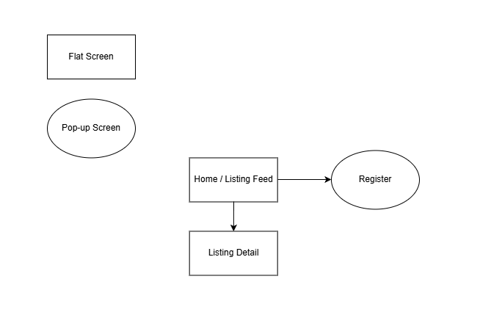

Buyer Screen Flow:
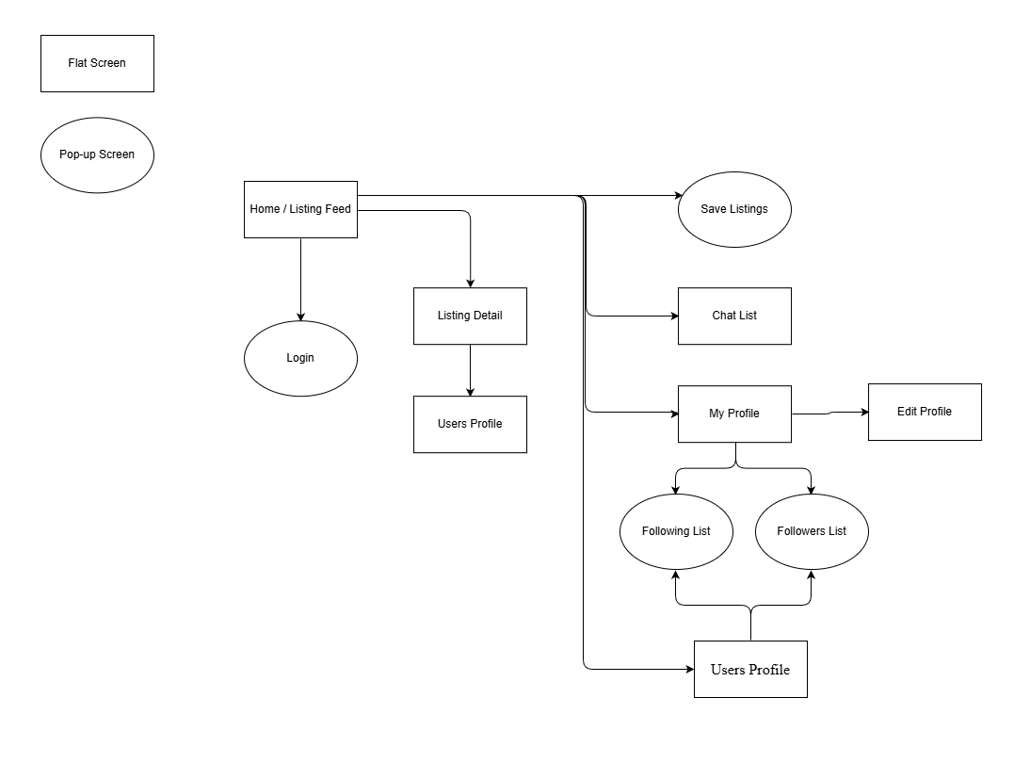

Seller Screen Flow:
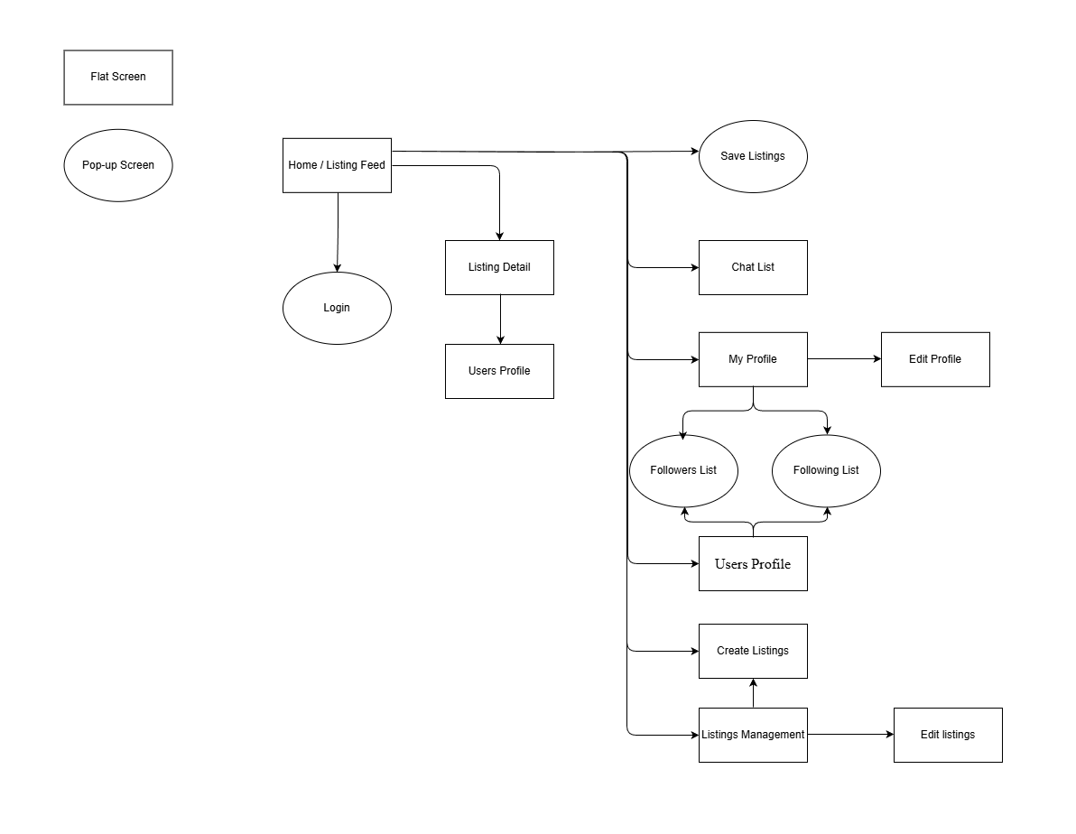

Admin Screen Flow:
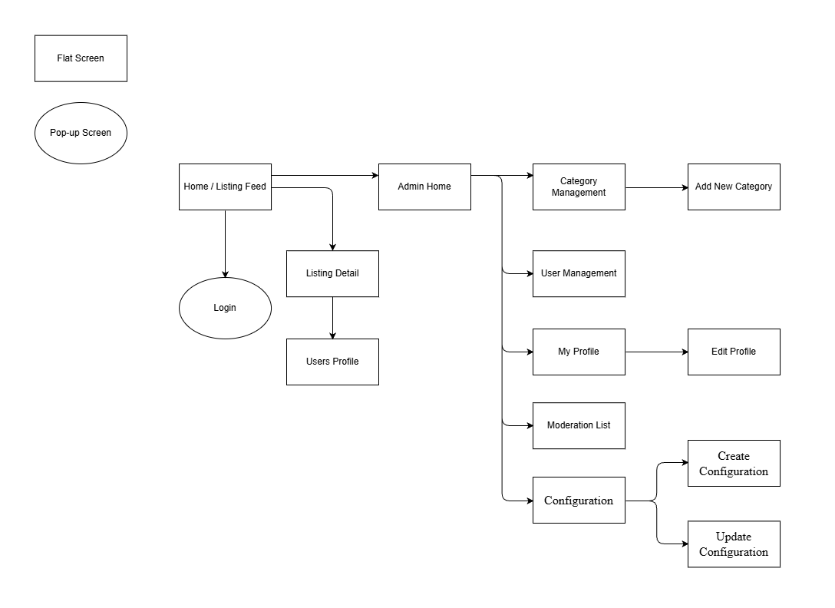

3.1.2 Screen Descriptions

# | Feature | Screen | Description
1 | Listing Browsing | Home / Listing Feed | The landing page that introduces the system. Displays a social-style feed of listings. The feed supports multiple viewing modes, including followed-based and recommendation-based filters.
2 | Authentication | Login | Allows users to log into the system using their account, email and password.
3 | Authentication | Register | Provides a screen for users to create new accounts.
4 | Listing Browsing | Listing detail | Shows detailed information of a selected feed, and below is the comment section.
5 | Messaging | Chat List | Displays a list of conversations grouped by listings. Each conversation represents a discussion between a buyer and a seller about a specific listing.
6 | Listing Management | Create Listings | Allows sellers to create a new listing by entering product information and publishing it to the system.
7 | Listing Management | Edit Listings | Allows sellers to modify the information of their existing listings.
8 | Administration | User Management | Allows administrators to manage user accounts and enforce account-level restrictions.
9 | User Account | Users Profile (Public) | Displays public information of a user, including posted listings and basic reputation indicators. This screen is accessible by other users.
10 | User Account | My Profile (Private) | Allows users to view and manage their own account information, including personal details, account settings and transaction history. This screen is only accessible by the account owner.
11 | User Account | Edit Profile | Allows users to edit their personal information and account details. This screen is only accessible by the account owner.
12 | User Interaction | Following List | Allow users to view the list of users that they have followed for later reference.
13 | User Interaction | Followers List | Allow users to view the list of users that are following you for later reference.
14 | User Interaction | Saved Listings | Allows buyers and sellers to view and manage the list of listings they have saved for later reference.
15 | Administration | Admin Home | Provides administrators with an overview of system activities and management tools.
16 | Administration | Moderation List | Displays reported listings or users for administrators to review and take moderation actions.
17 | Administration | Category Management | Enables admin to manage product categories, to ensure accurate and consistent item classification.
18 | Administration | Add New Category | Allows admin to add new categories, ensuring that listings can be properly classified and managed within the system.
19 | Administration | Configuration | Allows admin to to configure and update system settings to control platform behavior, operational rules, and global parameters.
20 | Administration | Add Configuration | Allows admin to add new system configuration settings.
21 | Administration | Update Configuration | Allows admin to update existing system configuration settings.
22 | Listing Management | Listings Management | Provides sellers with the ability to manage all their listings.

3.1.3 Screen Authorization

Screen | Guest | User (Buyer) | User (Seller) | Admin | Google SSO | Mail Service
View Home / Listing Feed | X | X | X | X
Choose Feed Types |  | X | X
Choose Listing Type Badges (Urgent Sale, Free Item,...) | X | X | X | X
Save Listings |  | X | X
Unsave Listings |  | X | X
Report Listings |  | X | X
Block Users |  | X | X
Search | X | X | X | X
Filter (price, status,...) | X | X | X | X
View Notifications |  | X | X
Create Listings |  |  | X
Report Listings |  | X | X
Login with Google SSO |  | X | X | X | X
Send Email |  |  |  |  |  | X
View Listing Detail | X | X | X | X
View comment | X | X | X | X
Write Comment (tag users) |  | X | X | X
Edit Listings |  |  | X
View Users Profile (Public) | X | X | X | X
Report Users |  | X | X
Share Users |  | X | X
Follow Users |  | X | X
Unfollow Users |  | X | X
View My Profile (Private) |  | X | X
View Saved Listing |  | X | X
Hide Listings |  |  | X
View Following Users |  | X | X
View Followers |  | X | X
Delete Listings |  |  | X
Edit My Profile |  | X | X | X
View Chat List |  | X | X
Chat |  | X | X
Rating Users |  | X | X
View Admin Home |  |  |  | X
View Users Management |  |  |  | X
View Category Management |  |  |  | X
Add New Category |  |  |  | X
Update Category |  |  |  | X
Delete Catedory |  |  |  | X
View Moderation Queue |  |  |  | X
View Reported Listings |  |  |  | X
Flag Users |  |  |  | X
Unban Users |  |  |  | X
View Configuration |  |  |  | X
Create Configuration |  |  |  | X
Update Configuration |  |  |  | X

3.1.4 Non-Screen Functions

# | Feature | System Function | Description
1 | Authentication | Check Authentication | Verifies user login credentials and validates authentication status before allowing access to protected system functions.
2 | Authorization | Check Role Permission | Checks user permissions based on assigned roles to control access to system features and screens.
3 | User Status Management | Check User Status | Determines whether a user account is active, or banned before processing requests.
4 | Student Verification | Verify Student Status | Validates student identity to ensure that only verified students can access platform features.
5 | Abuse Prevention | Rate Limiting | Limits the frequency of actions such as posting or reporting to prevent spam and system abuse.
6 | Audit & Logging | Admin Action Logging | Records administrative actions for auditing, monitoring, and accountability purposes.
7 | User Moderation | Evaluate User Flags | Monitors and counts user flags. Automatically bans accounts that exceed the allowed number of violations.

3.1.5 Entity Relationship Diagram
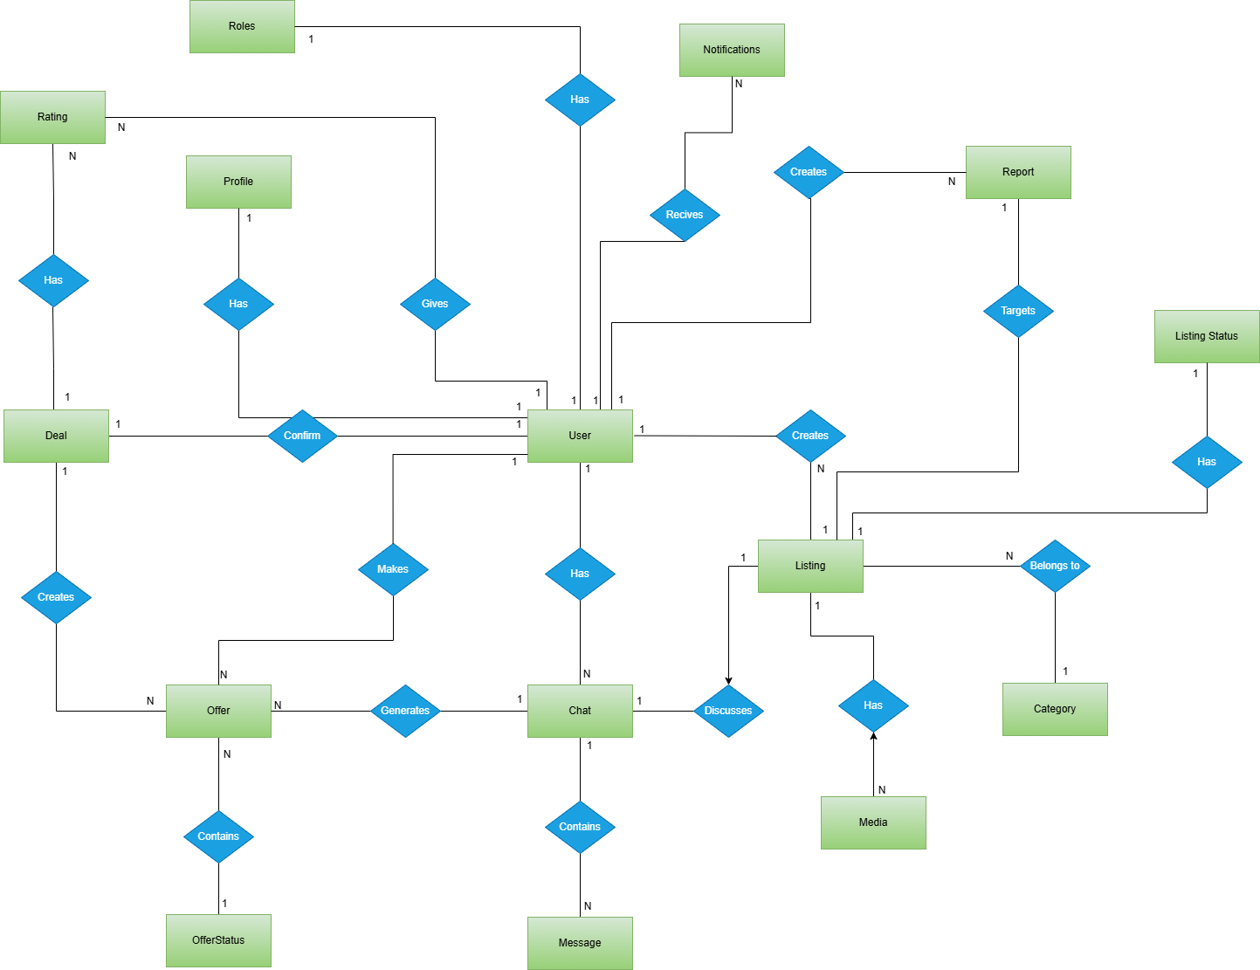

Entities Description
# | Entity | Description
1 | User | Represents a system user who can act as a buyer or seller. Users can create listings, participate in chats, make offers, confirm deals, give ratings, and create reports.
2 | Role | Defines the role assigned to a user in the system (e.g., User, Admin). Each user has exactly one role, which determines their permissions.
3 | Listing | Represents an item posted by a user for sale or giveaway. A listing belongs to one category, can have multiple media files, can be discussed in chats, and can be reported by users.
4 | Category | Represents a classification for listings (e.g., Electronics, Furniture). Each category can contain multiple listings, while each listing belongs to exactly one category.
5 | Media | Stores media files (images, videos) related to a listing. Each media item belongs to one listing, and a listing can have multiple media items.
6 | Chat | Represents a conversation between exactly two users regarding a specific listing. A chat contains multiple messages and can generate one or more offers.
7 | Message | Represents an individual message sent within a chat. Each message belongs to one chat and is sent by a user.
8 | Offer | Represents a price or condition proposal made by a user during a chat. An offer is created from a chat and can result in a deal if accepted.
9 | Deal | Represents a finalized agreement between two users after an offer is accepted. Each deal is created from exactly one offer and must be confirmed by a user.
10 | Rating | Represents a rating given by one user to another after a deal is completed. Ratings are associated with deals and reflect user trust and reputation.
11 | Report | Represents a report created by a user to flag inappropriate or suspicious listings. Each report targets one listing and is created by a user.
12 | ListingStatus | Represents the current state of a listing in the system. Each listing has exactly one listing status, while a listing status can be associated with multiple listings. This entity is used to manage the listing lifecycle such as active, hidden, sold, or removed.
13 | OfferStatus | Represents the current state of an offer. Each offer has exactly one offer status, and each offer status can be associated with multiple offers. This entity supports offer lifecycle management such as pending, accepted, rejected, or expired.
14 | Notification | Represents a system-generated message sent to a user to inform them about important events such as new messages, offers, deal confirmations, listing status changes, or reports. Each notification belongs to one user, and a user can receive multiple notifications.

3.2 Screen Specifications

3.2.1 Home / Listing Feed
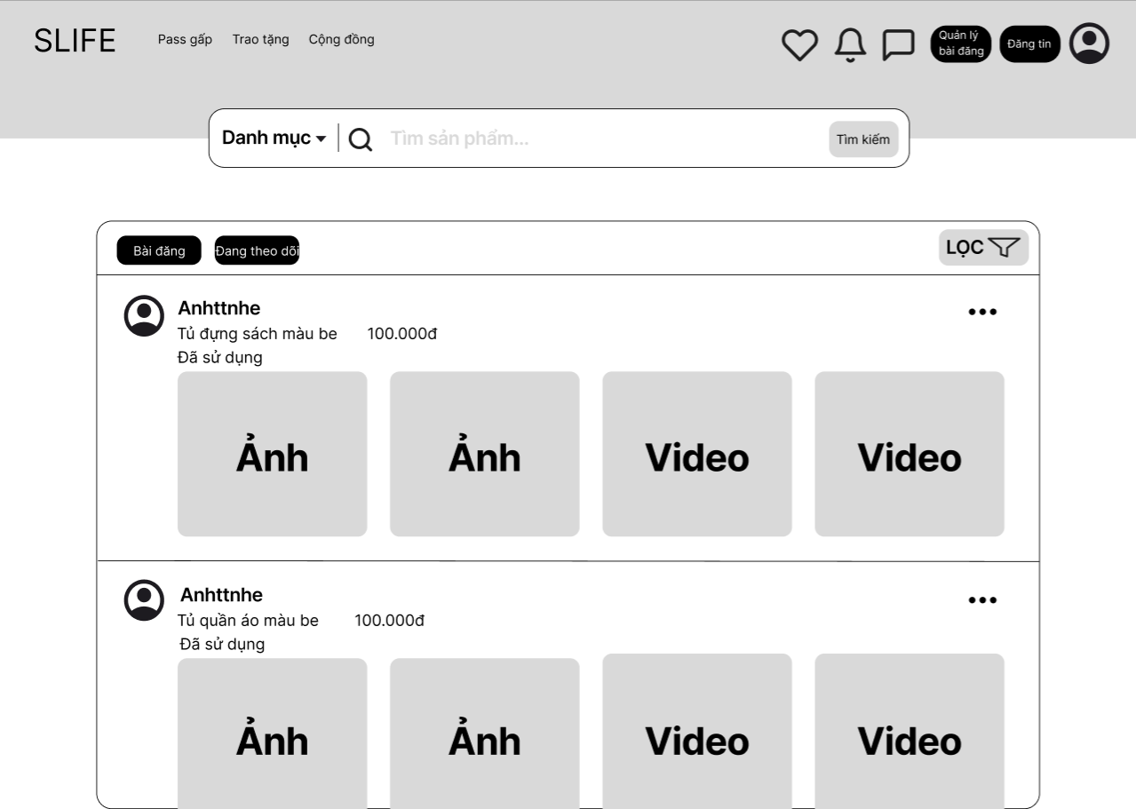

Field Name | Field Type | Description
Hình ảnh sản phẩm | Image/Carousel | Display the main and sub-images of the product.
Tên sản phẩm | Label | The title or name of the secondhand item.
Giá sản phẩm | Label | The selling price listed by the owner.
Trạng thái (Mới/Cũ) | Label/Tag | Indicates the current physical condition of the item.
Mô tả chi tiết | Text Area | Detailed text providing specifications or condition of the product.
Thông tin người bán | Group (Img/Label) | Shows the seller's name and profile picture.
Nhắn tin | Button | Opens a chat window to communicate with the seller.
Gọi điện | Button | Displays the seller's phone number or triggers a call.
Thêm vào yêu thích | Icon Button | Allows the user to save the product to their wishlist.
Sản phẩm liên quan | List/Cards | A section listing similar items based on category or price.
Quay lại | Icon/Link | Navigates the user back to the previous listing page.

3.2.2 Login
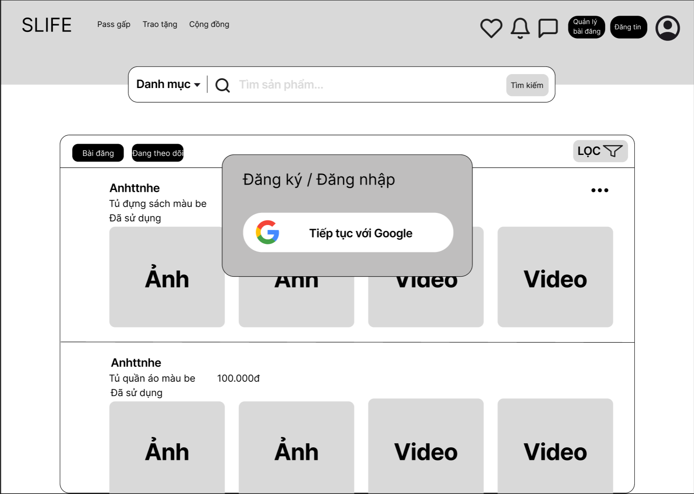

Field Name | Field Type | Description
Tiếp tục với Google | Button | Allows users to sign in using their FPT University Google account (@fpt.edu.vn).

3.2.3 Register


Field Name | Field Type | Description
Tiếp tục với Google | Button | Allows users to sign in using their FPT University Google account (@fpt.edu.vn).

3.2.4 Listing detail
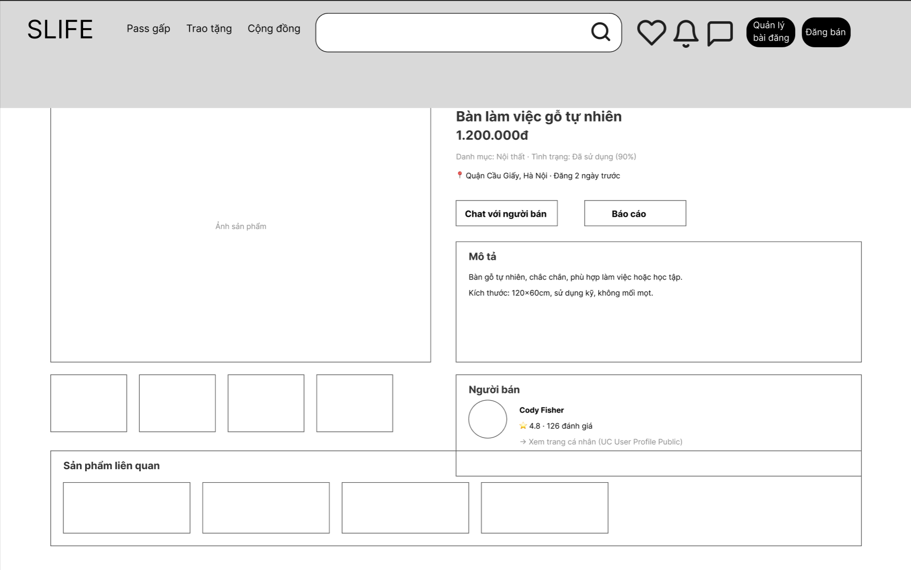

Field Name | Field Type | Description
Tìm sản phẩm... | Input | Enter keywords to search for products or services on the platform.
Pass gấp | Menu Item | Navigate to the "Urgent Sell" category section.
Trao tặng | Menu Item | Navigate to the "Giveaway/Donation" category section.
Cộng đồng | Menu Item | Navigate to the community discussion or group section.
Yêu thích (Heart icon) | Button/Icon | Click to add the current product to the user's wishlist.
Thông báo (Bell icon) | Button/Icon | Click to view system and personal notifications.
Tin nhắn (Chat icon) | Button/Icon | Click to open the conversation list or chat management.
Quản lý bài đăng | Button | Click to navigate to the user's personal post management dashboard.
Đăng bán | Button | Click to open the screen for creating a new product listing.
Chat với người bán | Button | Click to initiate a private conversation with the seller regarding this item.
Báo cáo | Button | Click to report the listing for violations or fraudulent content.
Xem trang cá nhân | Link | Click to view the public profile and other listings of the seller (Cody Fisher).
Ảnh sản phẩm (Main) | Image View | Display the primary high-resolution image of the product.
Thumbnail List | Image Gallery | A collection of smaller images that users can click to view different angles of the product.
Sản phẩm liên quan | List/Grid | Displays a list of similar items based on the current product category.

3.2.5 Chat List
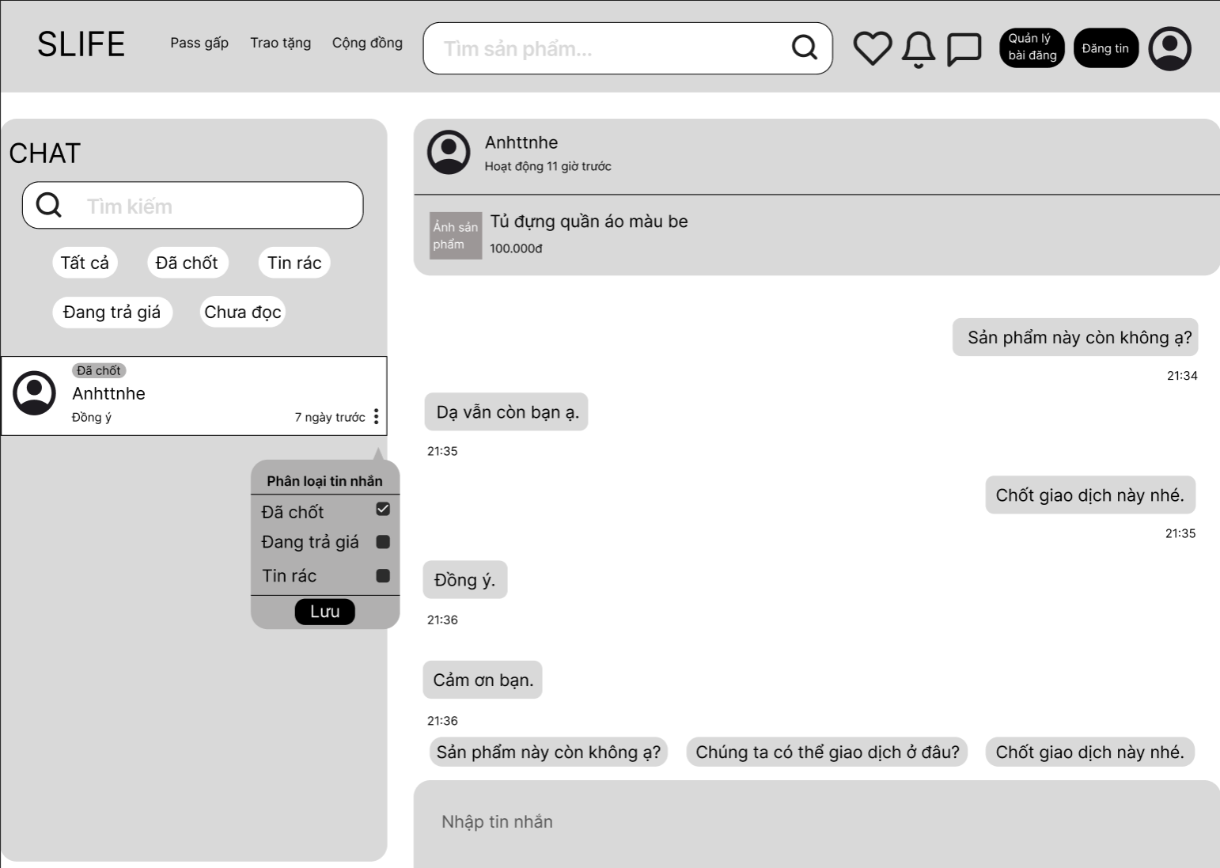

Field Name | Field Type | Description
Tìm kiếm | Input | Enter keywords to search for conversations or messages.
Tất cả | Button/Tab | Click to display all conversation history.
Đã chốt | Button/Tab | Click to filter conversations where deal are confirmed.
Tin rác | Button/Tab | Click to view messages marked as spam.
Đang trả giá | Button/Tab | Click to filter conversations with ongoing price negotiations.
Chưa đọc | Button/Tab | Click to filter messages that have not been opened yet.
Phân loại tin nhắn | Popup Menu | Select a category (Closed, Negotiating, Spam) to label the chat.
Lưu | Button | Click to save the selected message classification.
Nhập tin nhắn | Input | Click to save the selected message classification.
Sản phẩm này còn không ạ? | Quick Reply | Click to quickly ask for the meeting.

3.2.6 Create Listings
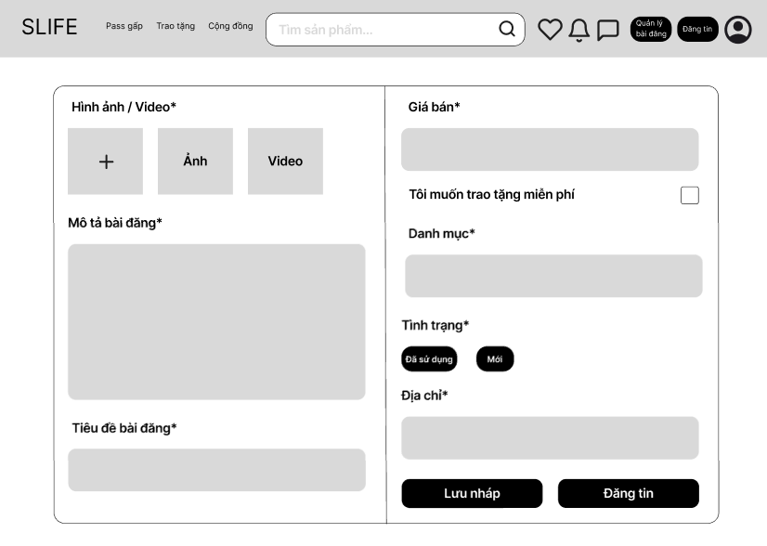

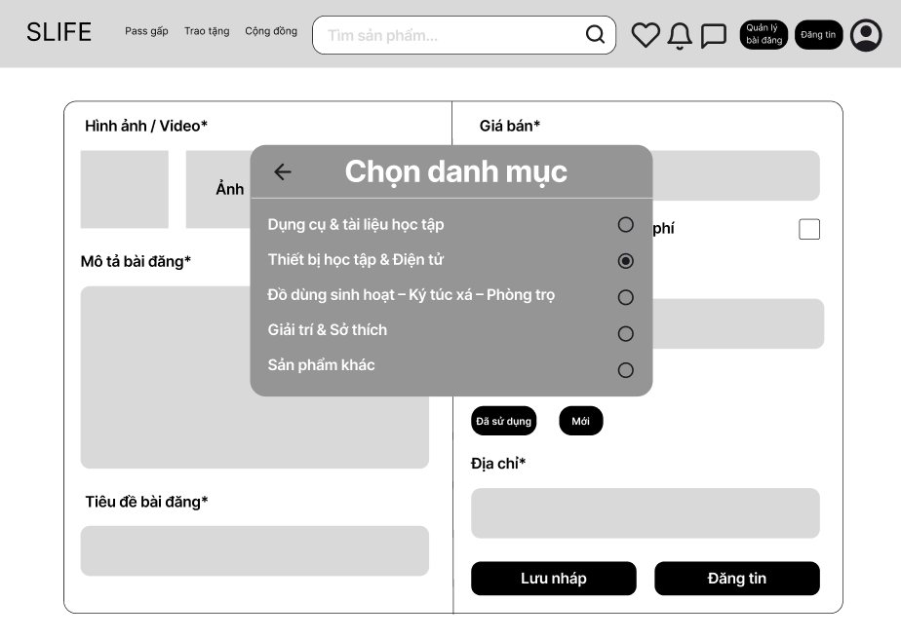

Field Name | Field Type | Description
Ô tìm sản phẩm | Textbox | Enter keyword to search for products.
Quản lý bài đăng | Button | Open the post management page.
Đăng tin | Button | Open the create new post page.
Biểu tượng tài khoản | Icon Button | Open the account menu.
Hình ảnh / Video* | Upload Area | Area to upload images or videos for the post.
Ảnh | Image Placeholder | Location to display the uploaded image.
Giá bán* | Textbox | Enter the selling price of the product.
Miễn phí | Checkbox | Mark the post as free of charge.
Mô tả bài đăng* | Text Area | Enter detailed description of the post.
Tiêu đề bài đăng* | Textbox | Enter the title of the post.
Đã sử dụng | Toggle Button | Select the condition as used.
Mới | Toggle Button | Select the condition as new.
Địa chỉ* | Textbox | Enter the transaction address.
Lưu nháp | Button | Save the post in draft status.
Đăng tin | Button | Publish the post to the system.
Chọn danh mục | Popup Panel | Window to select category for the post.
Nút quay lại | Icon Button | Return to the previous screen in category selection popup.
Dụng cụ & tài liệu học tập | Radio Option | Select the corresponding category.
Thiết bị học tập & Điện tử | Radio Option | Select the corresponding category.
Đồ dùng sinh hoạt – Ký túc xá – Phòng trọ | Radio Option | Select the corresponding category.
Giải trí & Sở thích | Radio Option | Select the corresponding category.
Sản phẩm khác | Radio Option | Select the corresponding category.

3.2.7 Edit Listings

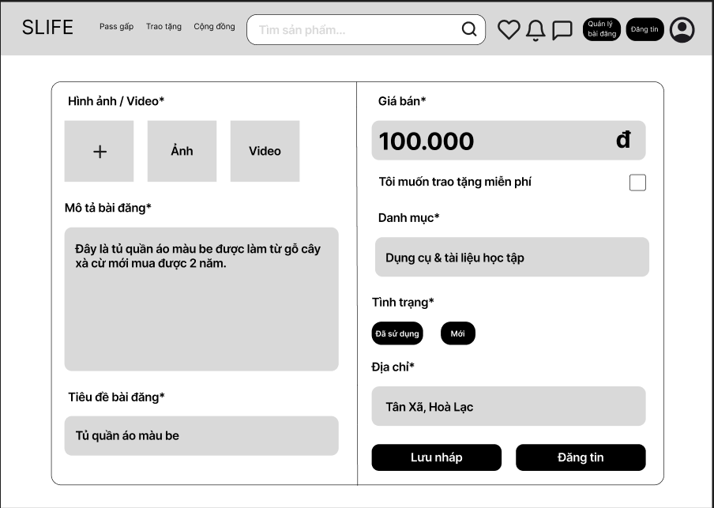

Field Name | Field Type | Description
Hình ảnh / Video* | Upload Area | Area to upload images or videos for the post.
Ảnh | Image Placeholder | Location to display the selected image.
Giá bán* | Textbox | Enter the selling price of the product.
Miễn phí | Checkbox | Select to post the item with a free price.
Mô tả bài đăng* | Text Area | Enter a detailed description for the post.
Tiêu đề bài đăng* | Textbox | Enter the title of the post.
Đã sử dụng | Toggle Button | Select the condition as used.
Mới | Toggle Button | Select the condition as new.
Địa chỉ* | Textbox | Enter the transaction address.
Lưu nháp | Button | Save the post as a draft.
Đăng tin | Button | Publish the post to the system.
Chọn danh mục | Popup Panel | Window to select product category.
Nút quay lại | Icon Button | Return to the previous screen in category popup.
Dụng cụ & tài liệu học tập | Radio Option | Select the corresponding category.

3.2.8 User Management

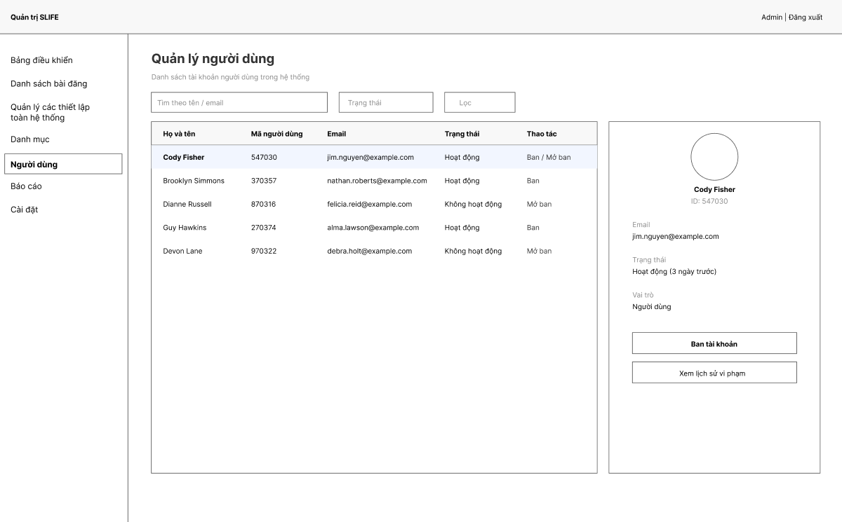

Field Name | Field Type | Description
Tìm theo tên / email | Textbox | Search users by full name or email; submit by Enter or search icon to refresh results.
Trạng thái | Text | Display current status of each user account (Hoạt động / Không hoạt động).
Lọc | Button | Apply filter conditions and reload user list.
Danh sách người dùng | Data Table | Display list of user accounts with basic information.
Thao tác | Button | Action control for each user row (Ban hoặc Mở ban tùy trạng thái).
Thông tin chi tiết người dùng | Info Panel | Show selected user profile including avatar, email, status, and role.
Ban tài khoản | Button | Disable selected user account.
Xem lịch sử vi phạm | Button | Navigate to violation history page of the user.
Admin | Label | Display current logged-in administrator name.
Đăng xuất | Link/Button | Log out from admin system.
Menu Người dùng | Navigation Link | Open User Management screen from sidebar.

3.2.9 Users Profile (Public)

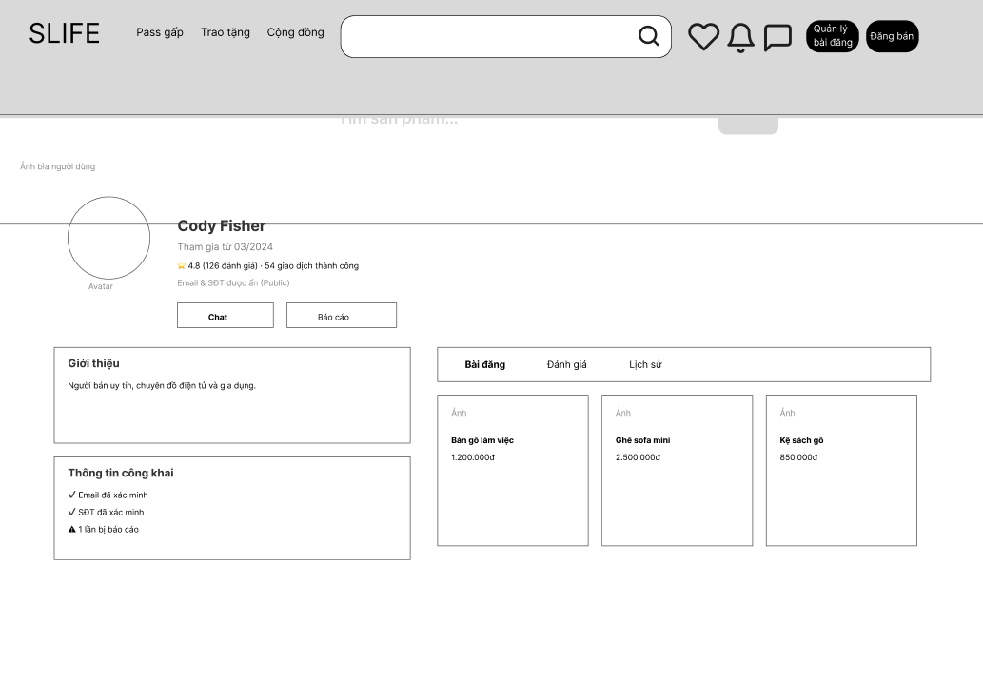

Field Name | Field Type | Description
Ô tìm kiếm | Textbox | Input keyword to search products across the system.
Nút tìm kiếm | Button/Icon | Execute search based on entered keyword.
Yêu thích | Icon Button | Open list of favorite products of the user.
Thông báo | Icon Button | Open notification list.
Tin nhắn | Icon Button | Navigate to chat/message page.
Quản lý bài đăng | Button | Navigate to user post management page.
Đăng bán | Button | Navigate to create new post screen.
Avatar người dùng | Image | Display user profile picture.
Tên người dùng | Label | Display full name of the user.
Thời gian tham gia | Label | Show month and year when user joined system.
Đánh giá | Label | Display user rating score and number of reviews.
Số giao dịch thành công | Label | Show total completed transactions of user.
Email & SDT công khai | Label | Indicate contact information visibility status.
Chat | Button | Open chat with this user.
Báo cáo | Button | Report this user to administrator.
Giới thiệu | Text Area | Display user self-introduction information.
Thông tin công khai | Info Panel | Show verification status: email verified, phone verified, number of reports.
Tab Bài đăng | Tab Button | Display list of products posted by user.
Tab Đánh giá | Tab Button | Display reviews about the user.
Tab Lịch sử | Tab Button | Display transaction history of user.
Thẻ sản phẩm | Card | Show product image, title and price in user post list.

3.2.10 My Profile (Private)
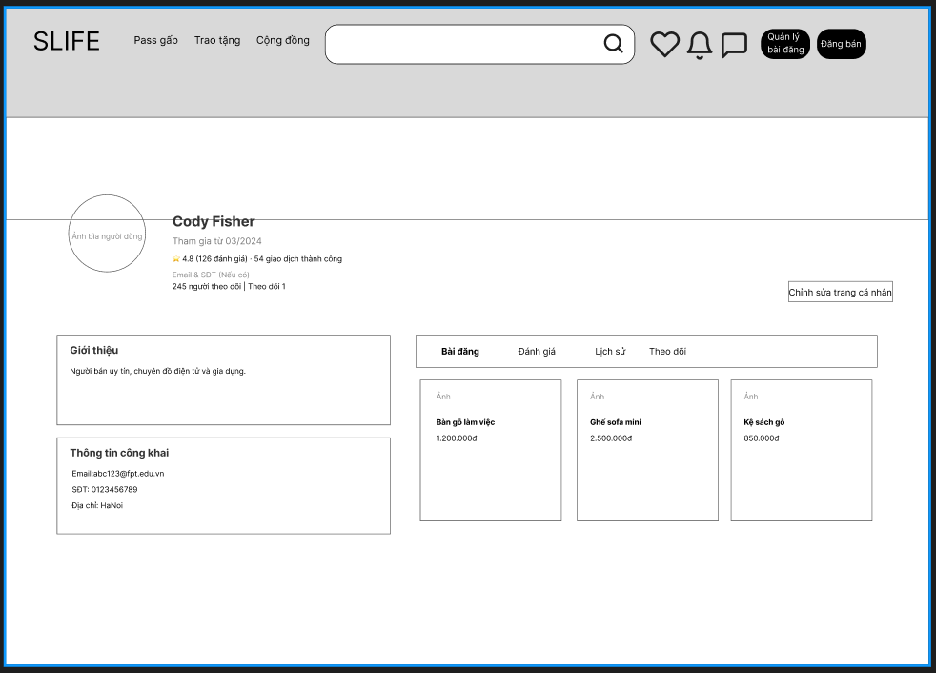

Field Name | Field Type | Description
Profile/Cover Photo | Image | Displays the user's avatar and banner.
Display Name | Text | The account holder's name (e.g., Cody Fisher).
Reputation Metrics | Label/Icon | Displays average star rating
Giới thiệu | Text | A short description of the user or their business expertise.
Thông tin công khai | List/Text | Contains contact details: Email, Phone Number, and Address.
245 người theo dõi | Theo dõi 1 | Text Link | Switch to the page with the list of followers and people being followed.
Navigation Tabs | Tabs | Switches between: Posts, Reviews, History
Own Product Grid | Card Grid | Displays items with Product Image, Title, and Price (VND).
Chỉnh sửa trang cá nhân | Button | This button is used to switch to the profile editing screen.
Email& SĐT | Text | Display the user's email and phone number if the user has one.

3.2.11 Edit Profile
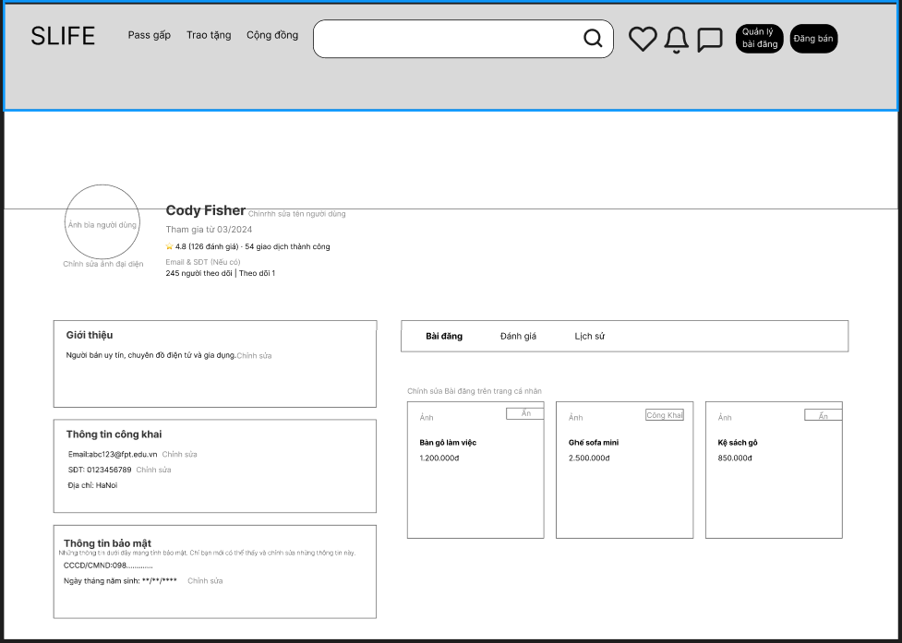

Field Name | Field Type | Description
Profile/Cover Photo | Image | Displays the user's avatar and banner. Allows uploading/updating in the edit screen.
Display Name | Text Area | The account holder's name. Allows uploading/updating in the edit screen.
Reputation Metrics | Label/Icon | Displays average star rating
Giới thiệu | Text Area | A short description of the user or their business expertise. Allows uploading/updating in edit mode.
Thông tin công khai | Text Area | Contains contact details: Email, Phone Number, and Address. Allows uploading/updating in edit mode.
Thông tin bảo mật | Text Area | Allows updating sensitive data like ID Card (CCCD/CMND) and Date of Birth, which remain masked for privacy.
Nút Ẩn và Công Khai trên bài đăng | Button / Label | Individual controls on each product card to switch between "Ẩn" (Hidden) and "Công Khai" (Public).
Navigation Tabs | Navigation Tabs | Sub-menus to view "Bài đăng" (Posts), "Đánh giá" (Reviews), and "Lịch sử" (History).

3.2.12 Following List
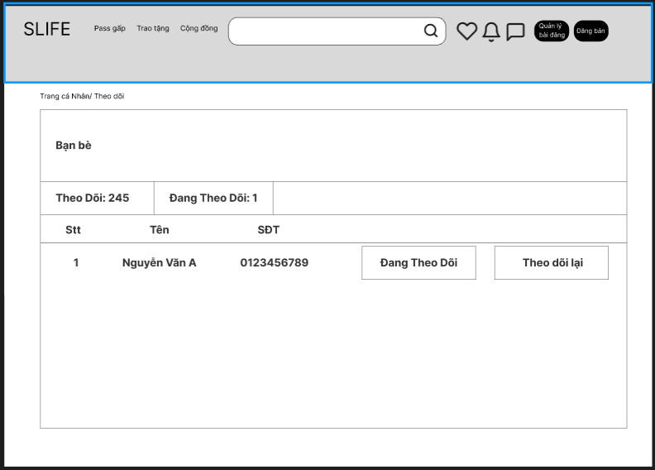
Field Name | Field Type | Description
Connection Tabs | Tabs | Switches between "Followers" (Theo dõi) and "Following" (Đang theo dõi).
STT | Number | Numeric order of users in the list.
Tên | Text/Link | The name of the connection; clickable to view their specific profile.
SĐT | Text | Contact number of the listed user.
Đang theo dõi | Button | Action button to "Unfollow" or indicates current "Following" status.
Theo dõi lại | Button | Quick action to follow a user who is already following you.
Trang cá nhân/ Theo dõi | Text/Link | Display the previous and next page order to quickly switch between them.

3.2.13 Followers List
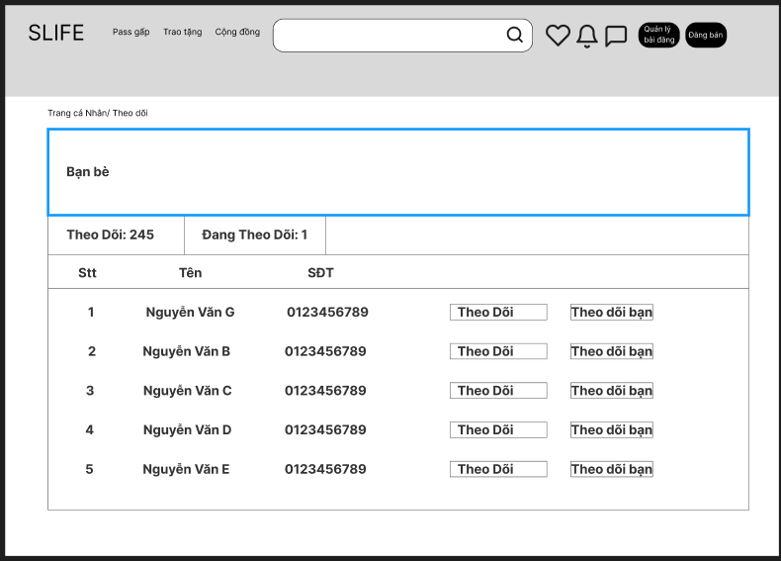

Field Name | Field Type | Description
Connection Tabs | Tabs | Switches between "Followers" (Theo dõi) and "Following" (Đang theo dõi).
STT | Number | Numeric order of users in the list.
Tên | Text/Link | The name of the connection; clickable to view their specific profile.
Theo dõi | Button | Allows the user to trigger a "Follow" (Theo dõi) action for listed users.
Theo dõi bạn | Label | Displays "Follows you" (Theo dõi bạn) to indicate a reciprocal or incoming connection.

3.2.14 Saved Listings
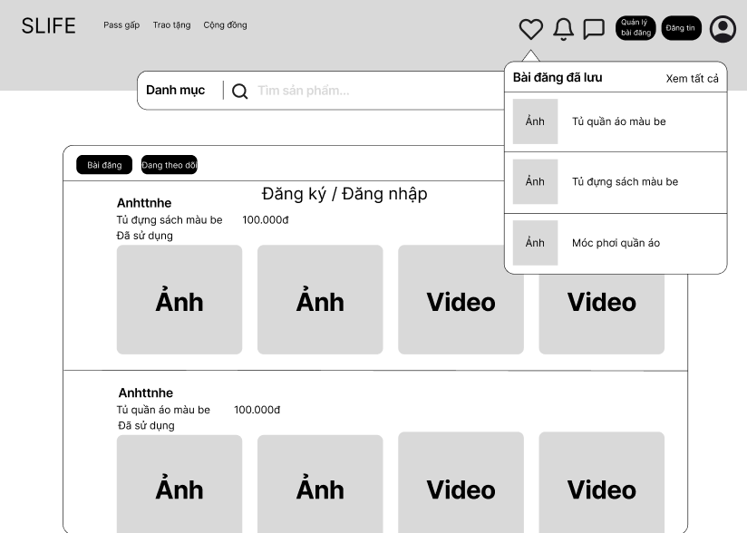

Field Name | Field Type | Description
Ô tìm sản phẩm | Textbox | Enter keyword to search for products.
Quản lý bài đăng | Button | Navigate to the post management page.
Đăng tin | Button | Navigate to the create new post page.
Biểu tượng tài khoản | Icon Button | Open the user account menu.
Popup Bài đăng đã lưu | Panel | Display the list of saved posts.
Xem tất cả | Link | Open the page to view all saved posts.
Ảnh (trong popup) | Image | Thumbnail image of the saved post.
Tên sản phẩm (trong popup) | Label | Name of the saved post.
Tab Bài đăng | Tab | Display the list of posts.
Tab Đang theo dõi | Tab | Display the list of followed posts.
Tên người đăng | Label | Display the name of the post owner.
Tên sản phẩm | Label | Display the product title.
Giá | Label | Display the product price.
Trạng thái | Label | Display the condition of the product.
Ảnh bài đăng | Image | Image illustrating the post.
Video bài đăng | Video | Video illustrating the post.

3.2.15 Admin Home
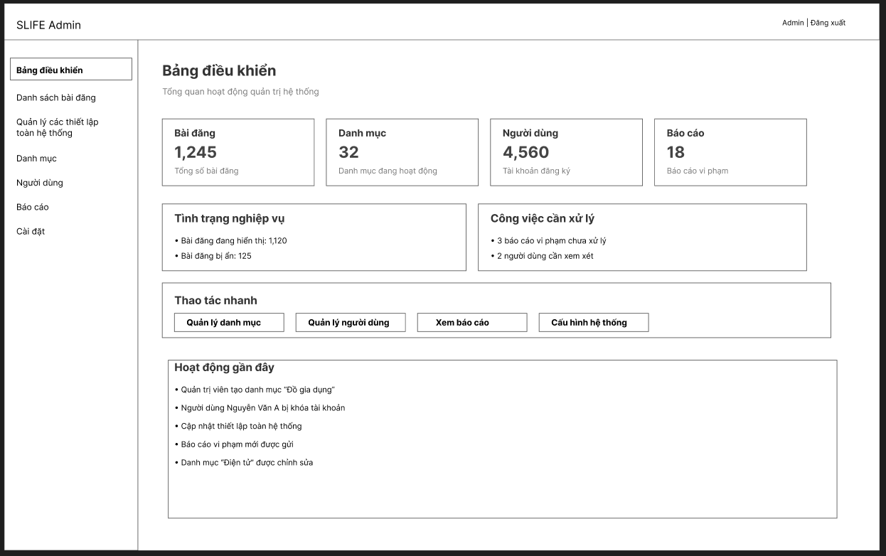

Field Name | Field Type | Description
Sidebar Navigation | Sidebar | Links to "Dashboard" (Bảng điều khiển), "Danh sách bài đăng",”Quản lý các thiết lập toàn hệ thống”,”Danh mục”,”Người dùng”, "Báo cáo", and "Cài đặt".
Bài đăng | Info Card | Displays the total number of posts currently on the platform (e.g., 1,245 posts).
Danh mục | Info Card | Displays the total number of active product categories (e.g., 32 categories).
Người dùng | Info Card | Displays the total count of registered user accounts (e.g., 4,560 accounts).
Báo cáo | Info Card | Displays the total number of violation reports submitted by users (e.g., 18 reports).
Tình trạng nghiệp vụ | List / Text | Shows a breakdown of post status: count of visible posts (1,120) versus hidden posts (125).
Công việc cần xử lý | Alert List | Highlights urgent administrative actions required: unprocessed violation reports and users pending review.
Thao tác nhanh | Button Group | Direct shortcuts to key management functions: Quản lý danh mục, Quản lý người dùng, Xem báo cáo, and Cấu hình hệ thống.
Hoạt động gần đây | Timeline Log | A chronological feed of the latest administrative actions, such as creating categories, locking user accounts, or updating system settings.

3.2.16 Moderation List
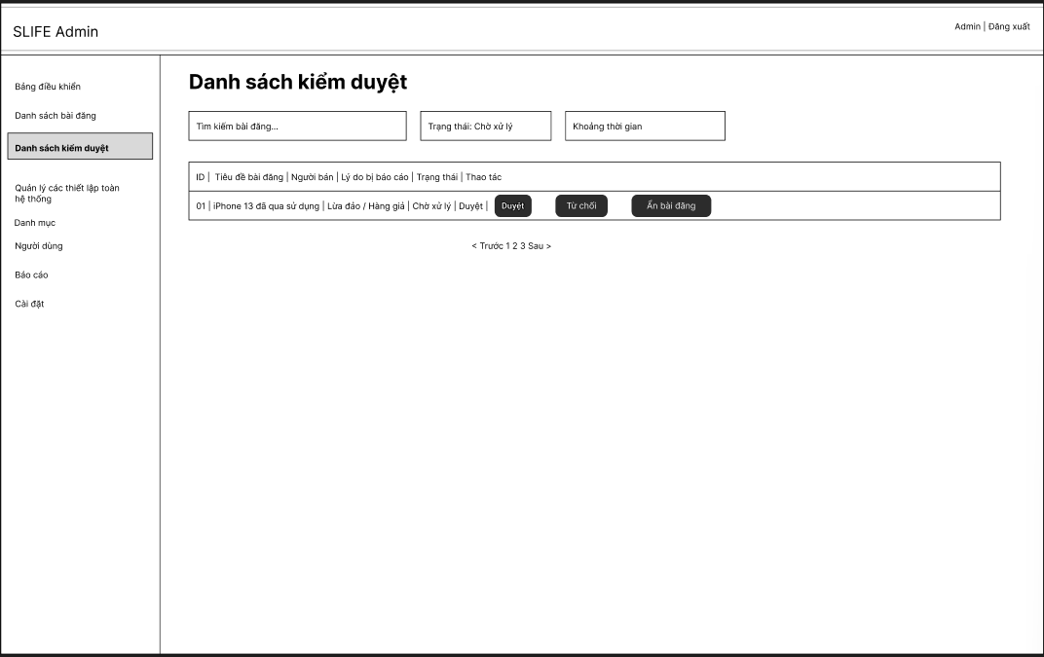

Field Name | Field Type | Description
Tìm kiếm bài đăng | Input | Allows admin to search for listings based on keywords.
Trạng thái | Dropdown | Allows admin to filter listings by moderation status.
Khoảng thời gian | Date Range Picker | Allows admin to filter listings by a specific time period.
Danh sách listings | Table | Displays a list of reported or pending listings for moderation.
ID | Text | Displays the unique identifier of the listing.
Tiêu đề listing | Text | Displays the title of the listing.
Người bán | Text | Displays the user who created the listing.
Lý do bị báo cáo | Text | Displays the reason the listing was reported.
Trạng thái | Status Label | Displays the current moderation status of the listing.
Duyệt | Button | Allows admin to approve the selected listing.
Từ chối | Button | Allows admin to reject the selected listing.
Ẩn listing | Button | Allows admin to hide the listing from public view.
Phân trang | Pagination | Allows admin to navigate between pages of results.

3.2.17 Category Management
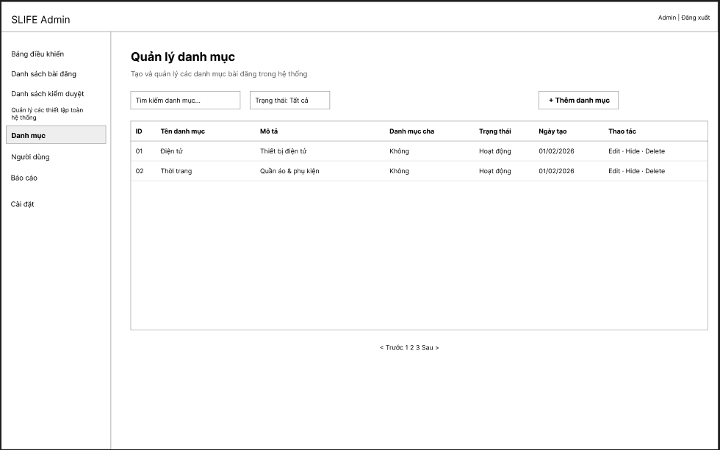

Field Name | Field Type | Description
Tìm kiếm danh mục | Textbox | Enter keywords to search for categories.
Trạng thái: Tất cả | Dropdown | Filter categories based on active status.
+ Thêm danh mục | Button | Open the function to create a new category.
Bảng danh mục | Data Table | Display the list of categories in the system.
Thao tác | Button | Provide Edit – Hide – Delete functions for each category.

3.2.18 Add New Category
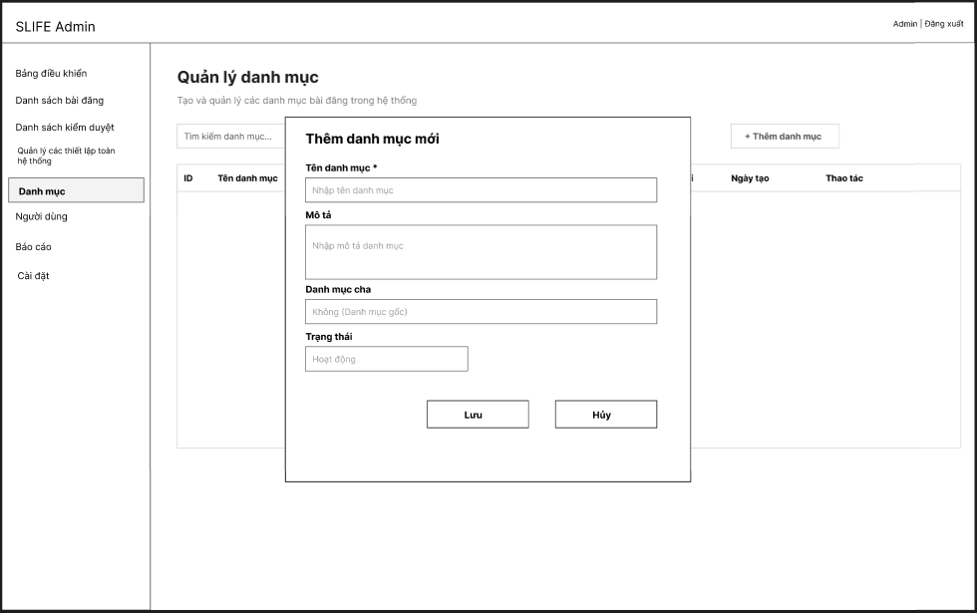

Field Name | Field Type | Description
Tên danh mục * | Textbox | Enter the name of the new category.
Mô tả | Text Area | Enter the description for the category.
Danh mục cha | Dropdown/Textbox | Select a parent category or leave as default none.
Trạng thái | Dropdown | Select the status of the category.
Lưu | Button | Save the new category information.
Hủy | Button | Close the popup and cancel the action.

3.2.19 Configuration
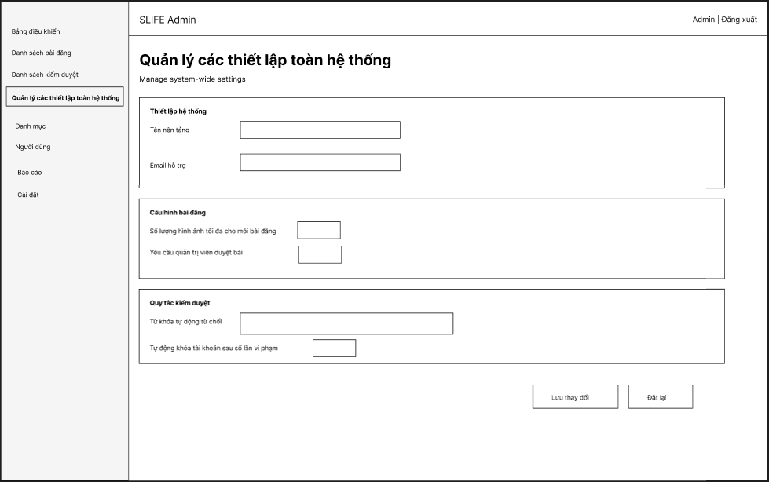

Field Name | Field Type | Description
Tên nền tảng | Textbox | Enter the platform name of the system.
Email hỗ trợ | Textbox | Enter the email address used for user support.
Số lượng hình ảnh tối đa cho mỗi bài đăng | Textbox | Define the maximum number of images allowed in a single post.
Yêu cầu quản trị viên duyệt bài | Checkbox | Determine whether posts must be approved by an administrator before being published.
Từ khóa tự động từ chối | Text Area | List keywords that will cause a post to be automatically rejected.
Tự động khóa tài khoản sau số lần vi phạm | Textbox | Set the number of violations after which a user account will be automatically locked.
Lưu thay đổi | Button | Save all changes to the system settings.
Đặt lại | Button | Reset all settings to their previous values.

3.2.20 Add Configuration

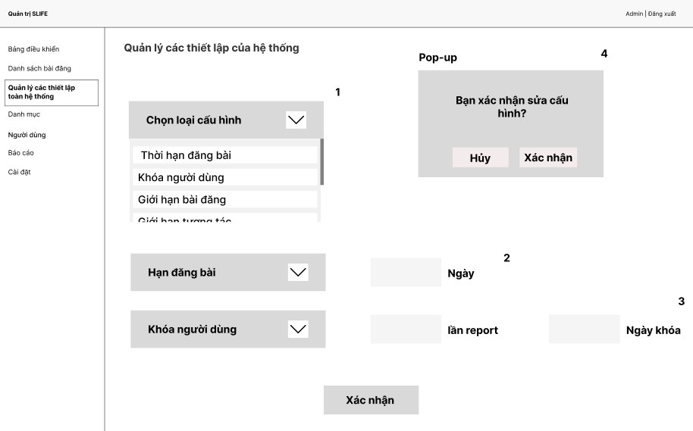

Field Name | Field Type | Description
Chọn loại cấu hình | Dropdown | Select the configuration category to be modified.
Thời hạn đăng bài | Dropdown Option | Configure the expiration period of a post.
Khóa người dùng | Dropdown Option | Configure the user lock policy.
Giới hạn bài đăng | Dropdown Option | Configure the limit for user posts.
Giới hạn tương tác | Dropdown Option | Configure interaction restrictions on the system.
Hạn đăng bài | Dropdown | Select the post expiration setting.
Ngày | Textbox | Enter the number of days a post remains active.
Khóa người dùng | Dropdown | Select the user lock configuration.
lần report | Textbox | Number of reports required to lock a user account.
Ngày khóa | Textbox | Duration (in days) that the account will be locked.
Xác nhận | Button | Save all configuration changes.

3.2.21 Update Configuration



Field Name | Field Type | Description
Chọn loại cấu hình | Dropdown | Select the configuration category to be modified.
Thời hạn đăng bài | Dropdown Option | Configure the expiration period of a post.
Khóa người dùng | Dropdown Option | Configure the user lock policy.
Giới hạn bài đăng | Dropdown Option | Configure the limit for user posts.
Giới hạn tương tác | Dropdown Option | Configure interaction restrictions on the system.
Hạn đăng bài | Dropdown | Select the post expiration setting.
Ngày | Textbox | Enter the number of days a post remains active.
Khóa người dùng | Dropdown | Select the user lock configuration.
lần report | Textbox | Number of reports required to lock a user account.
Ngày khóa | Textbox | Duration (in days) that the account will be locked.
Xác nhận | Button | Save all configuration changes.

3.2.22 Listings Management
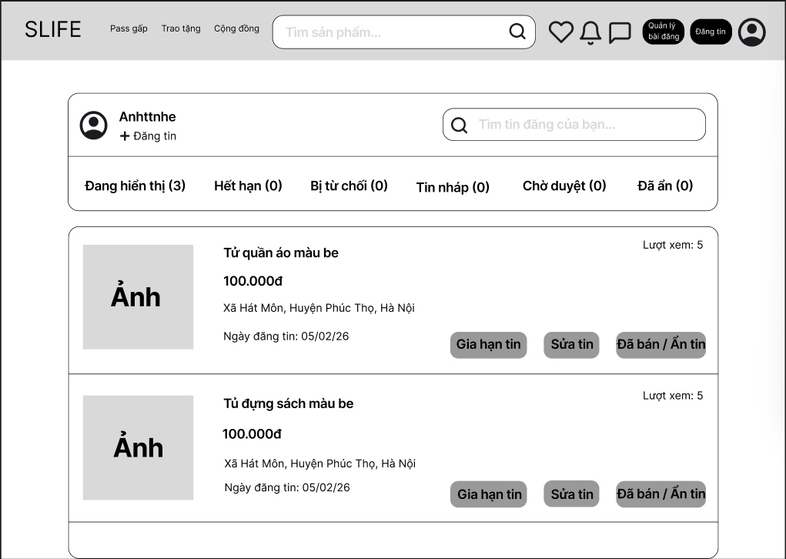

Field Name | Field Type | Description
+ Đăng tin | Button | Navigate to create new post page.
Ô tìm tin đăng của bạn | Textbox | Enter keywords to search user posts.
Đang hiển thị (3) | Tab | Show currently active posts.
Hết hạn (0) | Tab | Show expired posts.
Bị từ chối (0) | Tab | Show rejected posts.
Tin nháp (0) | Tab | Show draft posts.
Chờ duyệt (0) | Tab | Show posts waiting for approval.
Đã ẩn (0) | Tab | Show hidden posts.
Ảnh | Image | Display product image.
100.000đ | Label | Display product price.
Xã Hát Môn, Huyện Phúc Thọ, Hà Nội | Label | Display product address.
Ngày đăng tin: 05/02/26 | Label | Display posting date.
Lượt xem: 5 | Label | Display number of views.
Gia hạn tin | Button | Extend post duration.
Sửa tin | Button | Edit the post.
Đã bán / Ẩn tin | Button | Mark post as sold or hide post.

4. Non-Functional Requirements

4.1 External Interface

4.1.1 User Interface
- The system shall provide a web-based user interface accessible via modern web browsers.
- The user interface shall support the following main functionalities:
  - Viewing product listings with pagination
  - Real-time or near real-time chat between Buyer and Seller
  - Creating listings, commenting, rating, and reporting violations

4.1.2 Software Interfaces
- The system shall interact with a database to store and manage:
  - User information
  - Product listings
  - Chat messages
  - Ratings and complaints/reports

4.2 Quality Attributes

4.2.1 Usability

ID | Requirement
NFR-U1 | Core user flows (view listings, chat, create listings) shall be completed with the minimum possible number of steps.
NFR-U2 | Mandatory input fields shall be limited to essential information only.
NFR-U3 | The system shall display clear and understandable error messages when an action is rejected.

5. Requirement Appendix

5.1 Business Rules

ID | Rule Definition
BR-01 | A seller can only view product listings that they have created.
BR-02 | Only the seller who owns the listing can view hidden listings.
BR-03 | Product name and price are mandatory fields.
BR-04 | Only active listings and draft listings can be edited.
BR-05 | Deleted listings cannot be restored.
BR-06 | Required fields must not be left blank.
BR-07 | A product can only be relisted if it belongs to the seller.
BR-08 | Draft listings are not visible to buyers.
BR-9 | Sellers can only reply to comments on their own product listings.
BR-10 | Each giveaway product can only be assigned to one recipient.
BR-11 | Only active products can be marked as giveaways.
BR-12 | The system must display a giveaway badge on the product listing.
BR-13 | Sellers can confirm only one recipient per giveaway product.
BR-14 | The product status is updated to “Given Away”.
BR-15 | Only users with admin roles can access the dashboard.
BR-16 | Only administrators can view the full user list.
BR-17 | Search results must match the entered keyword.
BR-18 | When a user reaches three flags, the system automatically bans the user.
BR-19 | Configuration names must be unique.
BR-20 | A banned user must not be able to log into the system or perform any actions.
BR-21 | Only administrators can view and manage product categories.
BR-22 | Category names must be unique.
BR-23 | Category names must remain unique after editing.
BR-24 | Only administrators can access the moderation queue.
BR-25 | Only administrators can review reports.
BR-26 | Hidden products must not appear in buyer search results or listings.
BR-27 | Users must be authenticated to perform any interactive actions in the system.
BR-28 | Guest users can only access publicly available information in read-only mode.
BR-29 | Buyer and Seller roles are determined by user behavior, not by fixed account types.
BR-30 | Only sellers are allowed to create and manage their own product listings.
BR-31 | Newly created listings must have a default status of Draft.
BR-32 | Only listings with Active status are visible to buyers.
BR-33 | Administrators are allowed to hide or remove violating listings without deleting the underlying data.
BR-34 | Users who are suspended or banned are not allowed to send new chat messages.
BR-35 | Each buyer can submit only one rating per seller for a specific listing.
BR-36 | Valid rating values must range from 1 to 5 stars.
BR-37 | Disciplinary actions on users must not remove existing system data.
BR-38 | Restricted users are not allowed to create listings, send messages, post comments, or submit reports.
BR-39 | Violations may be handled progressively, including warning, temporary restriction, and permanent ban.

5.2 Common Requirements

ID | Rule Definition
CR-01 | All actions requiring authentication must be performed within a valid login session.
CR-02 | After successful login, users shall be redirected to the listings page.

5.3 Application Messages List
# | Message code | Message Type | Context | Content
1 | MSG01 | In line | There is not any search result. | No search results.
2 | MSG02 | In red, under the text box | Input-required fields are empty. | The * field is required.
3 | MSG03 | Toast message | Updating asset(s) information successfully. | Update asset(s) successfully.
4 | MSG04 | Toast message | Adding new assets successfully. | Add assets successfully.
5 | MSG05 | Toast message | Confirming email of asset hand-over is sent successfully. | A confirmation email has been sent to {email_address}.
6 | MSG06 | Toast message | Resetting asset information successfully. | Return asset(s) successfully.
7 | MSG07 | Toast message | Deleting asset information successfully. | Delete asset(s) successfully.
8 | MSG08 | In red, under the text box | Input value length > max length. | Exceed max length of {max_length}.
9 | MSG09 | In line | Username or password is not correct when clicking sign-in. | Incorrect user name or password. Please check again.
10 | MSG10 | Toast message | Profile information updated successfully. | Profile updated successfully.
11 | MSG11 | Toast message | Post visibility status changed (Public/Hidden). | Post visibility updated successfully.
12 | MSG12 | In red, under the text box | Invalid phone number format entered. | Please enter a valid phone number.
13 | MSG13 | Toast message | Successfully following another user. | You are now following {user_name}.
14 | MSG14 | Toast message | Successfully unfollowed a user. | Unfollowed successfully.
15 | MSG15 | Toast message | Admin successfully locks a user account. | Account {user_name} has been banned.
16 | MSG16 | Modal/Confirm | Confirmation before deleting an item or category. | Are you sure you want to delete this item? This action cannot be undone.
17 | MSG17 | Toast message | Violation report processed or resolved. | Report processed successfully.
18 | MSG18 | In red, under the upload box | The uploaded image exceeds the file size limit. | Image size exceeds the {limit}MB limit.
19 | MSG19 | Toast message | System configuration updated by Admin. | System configuration updated successfully.
20 | MSG20 | Modal/Alert | The user session has timed out. | Your session has expired. Please log in again.
21 | MSG21 | In line | Email format is incorrect. | Please enter a valid email address.
22 | MSG22 | Toast message | Password changed successfully. | Your password has been updated successfully.
23 | MSG23 | Modal / Alert | Permission denied for specific action | You do not have permission to perform this action.
24 | MSG24 | In line (Red) | Email or Phone number already exists | This {field_name} is already registered.
25 | MSG25 | Inline (Red) | Searching with empty or invalid keywords | Please enter the correct keyword to search.

